University of Virginia
Women, Gender & Sexuality
Fall 2015

Denise Walsh WGS 3810
Gibson Hall 454 Cabell 485
Office Hours: Tues. 6-7pm; Th. 2-3 pm T/Th 12:30-1:45
denise@virginia.edu

Feminist Theory

This course provides an overview of the historical roots and contemporary developments in feminist theory. We analyze a range of feminist theories, including liberal, Marxist, radical, and postmodern feminism. The course explores how feminist theory applies to a number of themes, including the body, sexuality, imperialism, globalization, and transnationalism. Throughout the course we address race, class, national, and cultural differences in feminist theory.

One of the most significant contributions of feminist theory has been to critically investigate how structures of power oppress, dominate, and exploit “others,” with a focus on women. Through the assigned readings and class discussions, students will learn how to use feminist tools from different traditions to analyze these multiple and intersecting forms of injustice.

The objectives of this course are 1) to provide an overview of feminist theory; 2) to examine competing foundations, arguments, and positions among feminist theories; 3) to develop the analytical skills needed to critically evaluate the assumptions, arguments, and debates among theorists; and 4) to use these skills in a final research project.

Course Requirements
Participation (20%)
Student attendance, preparation, and active participation in class are required. Come to class with questions. If you are shy in class, submit your written questions about the reading at the beginning of class or find another way to demonstrate your engagement with the material.

Questions to ask of all course readings and when doing all class assignments:
1. What is the question the author asks in the article? That is, what is the core problem that the author addresses?
2. What is the author’s claim? (How does s/he answer the question in #1?)
3. What evidence does the author present to support her/his claim? What does this evidence tell us? Why is it important for the argument? (note: this requires you to be familiar with specific examples from the reading).
4. What is your evaluation of the article? Are you convinced? What questions or criticisms does the author’s argument or use of evidence raise in your mind?
5. If there are problems or weaknesses, what constructive solution might you offer for resolving the issue or strengthening the argument?

Do not criticize our authors if you think that their ideas lack feasibility. Feminist theorists are not aiming to make a feasible argument, meaning one that would be adopted by the country in which you happen to be living at the time that you happen to be reading their article. Instead, most are aiming to set out ideals that can help us to criticize existing practices and policies and to inspire individual or collective action to advance change.

Lack of intellectual clarity is a legitimate criticism of an author; complaining that an author is difficult to understand or stating that you do not care for their writing style is not. If the assigned reading(s) are particularly challenging for you, highlight a concept or claim that you do not understand, explain what you think it may mean, and ask others for their views.

Discussion Leaders (15%)
In teams of 3, students will sign up for 10 minute presentations during one class session. Class sessions with discussion leaders are designated with an * on the syllabus. Students should meet beforehand to discuss the readings and plan content. Do not divide up the readings. All student presenters should be experts on all of the assigned material for their session. I expect a conversation between presenters. Assume everyone has done the reading.
Presentation requirements:
- Introduce the day’s topic with some historical background on a slide.
- Present the key question of each reading on a slide: 2 sentences maximum per reading. Take the time to discuss this slide so your audience can copy down the information and think about it.
- Present each author’s claim on a slide: 2 sentences maximum per reading. Take the time to discuss this slide so your audience can copy down the information and think about it.
- Discuss 2 pieces of evidence or arguments that you think best support the claim. Don’t read quotes or long pages of notes; instead, explain the ideas in everyday language.
- The instructor will stop any presentation that goes beyond 15 minutes.
- In addition to the 10 minute presentation students will design a 5-8 minute class activity, e.g., a mini debate, a film clip, small group activity. Be sure to explain the purpose of the activity exercise and its key points. Failure to do this is to fail the assignment.
- Name your powerpoint by the class number, e.g., Class5.ppt, and post it before class on Collab >Discussion and Private Messages>Worksite Discussions>Powerpoint Presentations>Post Reply.

Discussion leaders are not expected to be experts on the material. Instead of answers to the questions they also may pose suggested answers to the class and invite discussion.

Discussion Postings (30%).
Each student will post an entry on collab 10 times during the semester. Posts should be 550-600 words, address themes from all the assigned readings for that day, and present your views on issues raised by the authors. Students must engage with the comments of those who posted before them and raise a question for further discussion. You may summarize concepts, arguments, or debates, although the objective of your writing should be to raise questions and to take a critical position. Challenge a point, respond to a question, explain why your position is different, ask others what they think about a specific concept, argument, etc. Writing style matters. Be clear, concise, and respectful when disagreeing with others. This is classroom discussion online, not the blogosphere.

Postings are due before class. No late submissions will be accepted. It is your responsibility to make sure that you post 10 times Nov. 17. No posts will be accepted after Nov. 17. Students may not post on readings for which they are serving as discussion leaders. I will randomly select one of your completed posts to grade at mid-term and another one after midterm. Students are required to bring a hard copy of their posts to class.

To post, go to Collab >Discussion and Private Messages>Worksite Discussions>[class topic that you wish to post on]>Post Reply. Note: All posts should be in one thread. Do not start a separate thread.

Research Proposal (5%).
Proposals should have a one to two sentence question at the top of the page. Do not ask a question that you know what the answer will be before you do the research. If you already know the answer there is no point in doing the research project. Instead, ask a question that is puzzling to you so that you will learn something new. The proposal should also include two paragraphs describing why your question is important, explain how it relates to course themes and to your research plan.

The proposal must also have a correctly formatted bibliography with 3-5 outside sources plus several relevant course readings. Students will do additional activities related to the research project as detailed on the course outline.

Final Research Project (30%)
Students are required to conduct independent research for this paper and to use current sources. Students are expected to include a minimum of 5 outside sources in addition to relevant course readings. Your project might compare two feminist traditions, an apply a feminist theory to a particular topic (eg., abortion, the media, poverty), investigate one feminist theorist and her full body of work, explore how a particular feminist theory is relevant to your life and experience, etc.

Project Guidelines
All projects must be analytical, not merely descriptive. Descriptive projects answer the questions “what?” “when?” “who?” Analytical projects answer the questions “how?” and “why?” Use the analytical tools that we develop in class. If you are not sure what they are, ask. Do not turn in a project that offers a list of facts, people, events, or even ideas. Instead, focus on asking an interesting question that is narrow enough for you to answer in 10-12 pages or a comparably sized project product, and go as deeply as you can into that topic.

Research papers should be double-spaced, in 12 font, 10-12 pages, spell-checked, and include page numbers and a title. Format of citations and bibliography is up to you but be consistent. Proof read all written work. Complex ideas are best conveyed through simple language. Proper grammar, spelling, and writing style convey professionalism and excellence. Sign the honor code. Guidelines for research paper projects, as opposed to papers, will vary with the type of project. Consult the instructor during office hours for details.

Student who wish to receive written feedback on the final project must request it on the title page of the project materials.

Helpful Resources
The best resource available to you for writing in this course is the UVa Writing Center. Many college writing centers have extensive resources on writing and reading. Here is one example from UNC.

WGS has its own librarian. Ms. Purdom Lindblad can purchase resources that you need if they are not in the library and is available for individual research consultations. Contact her by email: jpl8e@eservices.virginia.edu. Also check out the WGS library in Minor Hall and the recommended readings on the syllabus.

Baffled by feminist theory terminology? Check out: Catharine R. Stimpson and Gilbert Herdt, 2014, Critical Terms for the Study of Gender, University of Chicago Press (in the library).

Extra Credit
Students may attend one extra credit event during the semester. If you think an event is course related and would like to attend, confirm with the instructor first. If the event is a talk, students should write a one page, single-spaced report of what they learned, and that includes the question that you asked at the talk and the speaker's response. The write-up must be turned in via email to the instructor within two weeks of the event and will count for up to 5 bonus points to be added to one of the student’s posting grades.

Course Policies
No computers, cell phone, ipads, etc. should ever be used during class without instructor permission.
Do not email me if we can discuss your question before or after class or during my office hours. I will not answer emails that do not follow this protocol.
Do not send me an email with a question that is answered on this syllabus. Always check with another student in the class first.
Use UVa Box to backup your work in real time; backup your entire computer on an external hard drive regularly. No extensions for lost work necessary because you will never lose work.
Do not eat lunch in class.
Follow the honor code. If you have a question about plagiarism, ask.
Students turn in all written work for this course on collab.
Late discussion postings and presentations from discussion leaders are not accepted.
Late research papers and proposals lose 3 points each day for the first two days. Later work will only be accepted as determined by the instructor.
All students are expected to attend every class session with the exception of illness or an emergency. All other absences will be unexcused and detract from your participation grade. In the event of an excused absence, arrange to get the information from another student in the class. Do not contact me for these items.
For information about my research, courses, advising, and letters of recommendation, please consult my website.

Required Readings
Betty Friedan, 1963, The Feminine Mystique, W.W. Norton & Company, Reprint edition 2013. Available new on Amazon.com for $12.

Linda Nicholson, ed., 1997, The Second Wave, Routledge. Available new on Amazon.com for $47.68. Readings from this book are marked (SW). You can find most of the readings from this book online, so the purchase is optional. Note that a few of the online readings are a bit longer than the excerpted versions in the book (as indicated on the syllabus). Some used copies should be available in the bookstore.

Brooke Ackerly and Jacqui True, 2010, Doing Feminist Research in Political Science and Social Science, Hampshire: Palgrave Macmillan. Available new on Amazon.com for $32.37. Some used copies should be available in the bookstore. You will need this book at the end of the semester. We will be reading the first half of the book, which is applicable to the humanities and social sciences. The first chapter, as well as exercises, guides, examples, and glossary are available online.

All three books are on reserve in Clemons Library. All other readings on the syllabus are available via the links on the syllabus or, if no link is provided, are on Collab.

*Occasional changes to the syllabus are possible and will be announced in advance.
NB: If you or someone you know is struggling with gender, sexual, or domestic violence, or is a target of a hate crime, there are many community and University of Virginia resources available including Just Report It, The Office of the Dean of Students: 434- 924-7133 (after hours and weekends 434-924-7166 for the University Police Department; ask them to refer the issue to the Dean on Call), the UVA Women's Center: 435-982-2361, Sexual Assault Resources Agency (SARA) hotline: 434-977-7273 (24/7), Shelter for Help in Emergency (SHE) hotline: 434-293-8509 (24/7). If you prefer to speak anonymously and confidentially over the phone to UVa student volunteers, call Madison House's HELP Line (24/7): 434-295-8255.

Course Outline
Part I. Theory and Method
Class 1 (Aug. 25): What is feminism?
Discussion of class policies, the syllabus, and assignments.

Paula Treichler and Cheris Kramarae, 1985, A Feminist Dictionary: In our Own Words, Pandora Press: 158-160.

bell hooks, 2000, “Feminism: A Movement to End Sexist Oppression” in Feminist Theory: From Margin to Center, Pluto Press: Ch. 2.

Recommended:
Nancy F. Cott, 1986, “Feminist Theory and Feminist Movements: The Past Before Us,” in Juliet Mitchell and Ann Oakley, What is Feminism? Pantheon: 49-62.

Johanna Brenner, 1993, "Best of Times, Worst of Times,” New Left Review, I/200, July-August.

Jennifer Baumgardner and Amy Richards, 2000, "What Is Feminism?" in Manifesta: Young Women, Feminism, and the Future, Farrar, Straus, and Giroux.
(Check them out on YouTube)

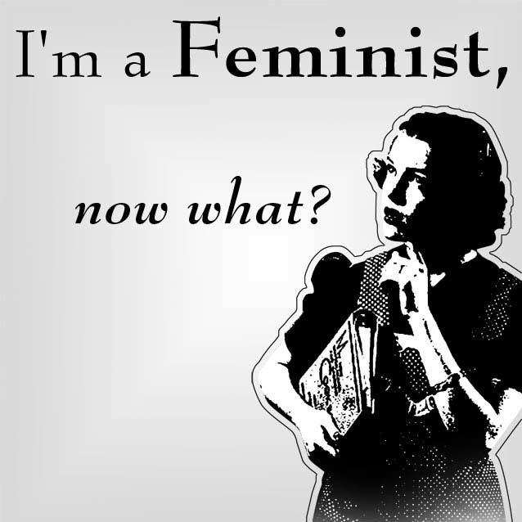

Class 2 (Aug. 27): What is feminist theory? What is it good for?
Charlotte Bunch, 1979, “Not by Degrees: Feminist Theory and Education” in Passionate Politics: Feminist Theory in Action, Macmillan: 240-253.
Check out this film clip about Bunch.

Maria C. Lugones and Elizabeth Spelman, 1983, “Have We Got a Theory for You!” Hypatia 6 (6): 573-581.

bell hooks, 1991, “Theory as Liberatory Practice.”
Check out this brief clip of bell hooks speaking about voice.

Recommended:
Wendy Kolmar and Frances Bartkowski, eds., 2010, 3rd edition, “Lexicon of the Debates,” Feminist Theory: A Reader, McGraw Hill: 42-60. NB: This reading has definitions of key terms and is available under the Resources Tab on Collab.

Class 3 (Sept. 1) and Class 4 (Sept. 3): CANCELLED. I will be in San Francisco at the annual American Political Science Association Conference.
Last Day to Add a Class: Sept. 8
Class 5 (Sept. 8): Feminist Methodology*
Sandra Harding, 1987, “From the Woman Question in Science to the Science Question in Feminism,” in The Science Question in Feminism, Cornell University Press: 15-29.

Uma Narayan, 2004, “The Project of Feminist Epistemology: Perspectives from a Nonwestern Feminist” in The Feminist Standpoint Theory Reader, Routledge: 213-224.

Recommended:
Nancy M. Hartsock, 1985, “The Feminist Standpoint: Developing the Ground for a Specifically Feminist Historical Materialism.”

Ruth Herschberger, 1948, “Josie Takes the Stand,” Adam’s Rib, Pellegrini and Cudahy.

Sandra Harding, 1991, Whose Science? Whose Knowledge? Thinking from Women’s Lives, Cornell University Press.

-----, 1992, “After the Neutrality Ideal: Science, Politics, and Strong Objectivity,” Social Research 59 (3): 567-587.

Haraway, Donna, 1985, The Haraway Reader, Routledge.

Donna Haraway, 2002, "Situated Knowledges: The Science Question in Feminism and the Privilege of Partial Perspective," in Carole R. McCann and Seung-Kyung Kim, eds., Feminist Theory Reader: Local and Global Perspectives, Routledge: 391-403.

Nancy Naples, 2003, Feminism and Method, Routledge.

Sandra Harding, 2006, Science and Social Inequality: Feminist and Postcolonial Issues, University of Illinois Press.

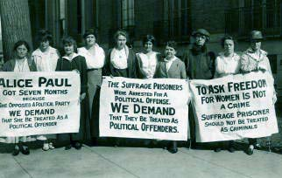
Last Day to Drop a Class: Sept. 9

Part II: The First Wave
Class 6 (Sept. 10): First Wave Liberal Feminism
Half the students will read Wollstonecraft and Truth; the other half will read Mill and al-Badiya.

Mary Wollstonecraft, 1792, Vindication of the Rights of Women: Ch. 1 and 2.

Sojourner Truth, 1867, “Ain’t I A Woman?” “Keeping the Thing Going While Things Are Stirring.”

John Stuart Mill, 1869, The Subjection of Women, Ch. 1.

Bahithat al-Badiya, 1990 [1909], “A Lecture in the Club of the Umma Party” in Margot Badran and Miriam Cooke, eds., Opening the Gates: A Century of Arab Feminist Writing, Indiana University Press: 228-238.

Recommended:
Joan Scott, 1996, "The Uses of Imagination: Olympe de Gouges in the French Revolution," in Only Paradoxes to Offer: French Feminists and the Rights of Man, Harvard University Press.

Charlotte Perkins Gilman, 1898, Women and Economics: A Study of the Economic Relation between Men and Women as a Factor in Social Evolution, Maynard and Co.

Frederick Douglass, 1882, “Why I Became a Woman’s-Rights Man,” in The Life and Times of Frederick Douglass, Written by Himself.

Mary Church Terrell, 1898, The Progress of Colored Women

Maria Eugenia Echenique, 1876, “The Emancipation of Women”

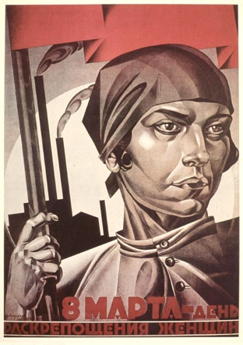
Class 7 (Sept. 15): First Wave Socialist and Marxist Feminism*
Alexandra Kollontai, 1909, “The Social Basis of the Woman Question.”

Friederich Engels, 2004 [1884], “The Family,” The Origin of the Family, Private Property and the State, Resistance Books: 45-87 (Ch. II in all versions).

Recommended:
Vladimer Ilich Lenin, 1975, The Emancipation of Women: From the Writings of V. I. Lenin, International Press.

Emma Goldman, 1910 [1971], The Traffic in Women and Other Essays on Feminism Times Change Press.

Rosa Luxembourg, 1912, “Women’s Suffrage and Class Struggle”

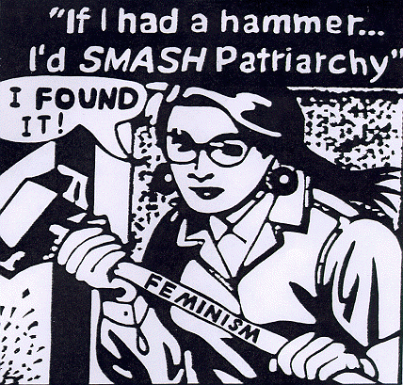

Part III. “Second Wave” Feminisms
Class 8 (Sept. 15): Existential Feminism
Toril Moi, 1999, What is a Woman? And Other Essays, New York: Oxford University Press: 10-21.

Simone de Beauvoir, 1952, “Introduction” to The Second Sex (SW #1).

Interview with Simone de Beauvoir, 1976, “The Second Sex 25 Years Later,” Society, Jan-Feb.

Recommended:
Simone de Beauvoir, 1952, The Second Sex.

Toril Moi, 1999, What is a Woman? And Other Essays, New York: Oxford University Press: 59-72.

Class 9 (Sept. 22): Second Wave Liberal Feminism*
Betty Friedan, 1963, The Feminine Mystique, W.W. Norton & Company, Reprint edition (2013): Ch. 1-3

Susan Faludi, 1991, Backlash, W.W. Norton & Company: Ch. 1.

Recommended:
Betty Friedan, Biography

Mad Men, Season 1 Episode 2 “Ladies Room”

Carol Pateman, 1988, “The Fraternal Social Contract,” in John Keane, ed., Civil Society and the State, Verso: 101-128.

Susan Okin, 1989, “Vulnerability by Marriage,” Justice Gender and the Family, Basic Books: 134-170.

Film: North Country

Elaine Showalter, 1971, Women’s Liberation and Literature, Harcourt Brace Jovanovich.

Martha Nussbaum, 2000, Sex and Social Justice, Oxford University Press.

Class 10 (Sept. 24): Radical Feminism
Gayle Rubin, 1984, Thinking Sex: Notes for a Radical Theory of the Politics of Sexuality, in Carole S. Vance, ed., Pleasure and Danger: Exploring Female Sexuality, Pandora Press: Ch. 9.

Catharine MacKinnon, 1989, “Sexuality,” Toward a Feminist Theory of the State, (SW #10). [The online version is about 4 paragraphs longer than the SW version).
*NB: This reading discusses sexual assault.

Recommended:
Kate Millett, 1969 [2000], “Theory of Sexual Politics,” Sexual Politics, University of Illinois Press.

Gayle Rubin, 1975, The Traffic in Women: Notes on the Political Economy,” in Rayna Reiter, ed., Toward an Anthropology of Women, Monthly Review Press: 770-794.

Shulamith Firestone, 1970, The Dialectic of Sex, (SW #2).

Mary Daly, 1978, Gyn/Ecology: The Metaethics of Radical Feminism, Beacon Press.

Radicalesbians, 1970, “The Woman-Identified Woman,” (SW #9).

Adrienne Rich, 1980, “Compulsory Heterosexuality and Lesbian Existence,” Signs: 631-60.

Catharine MacKinnon, 1993, Only Words, Harvard University Press.

Patricia MacFadden, 2003, “Sexual Pleasure as Feminist Choice,” Feminist Africa 2.

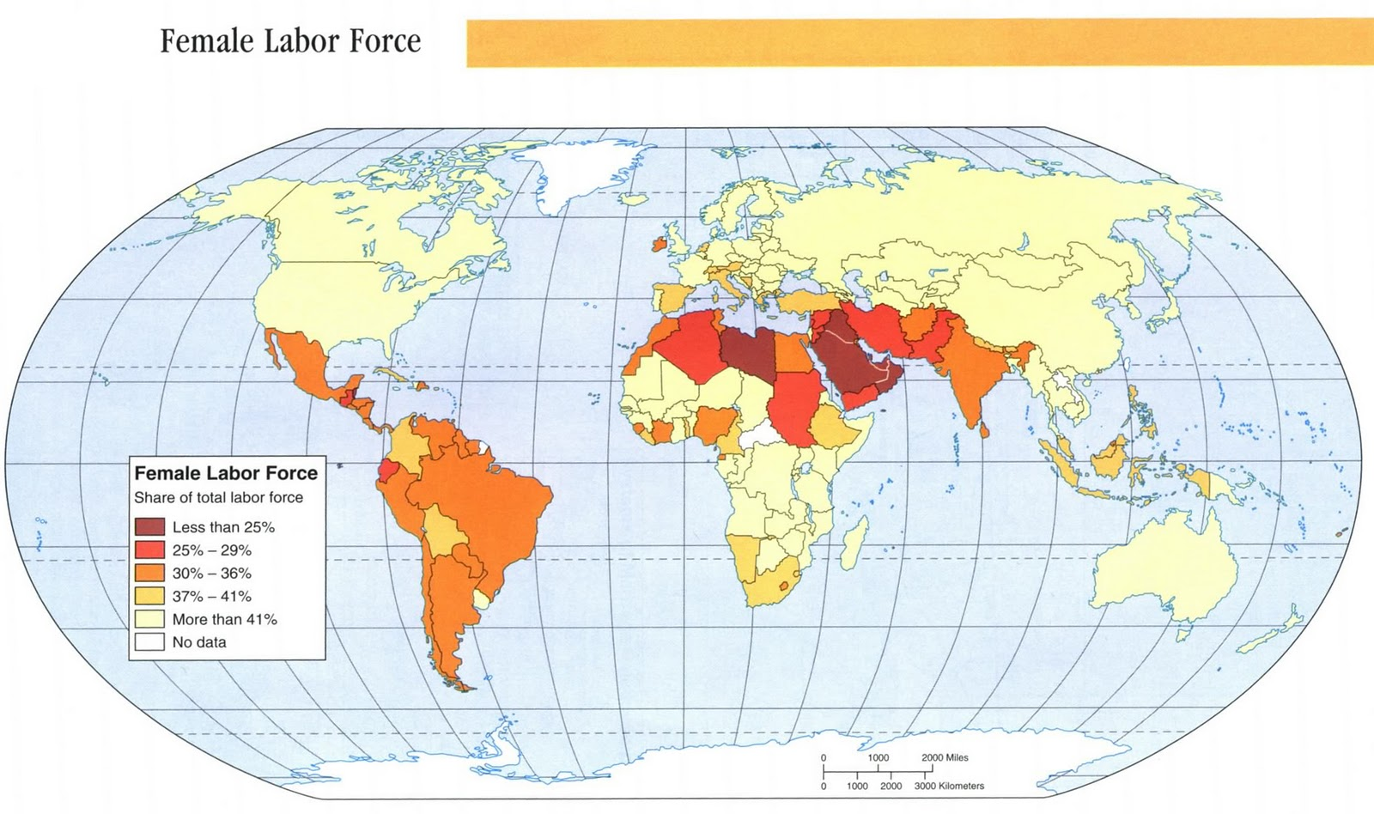

Class 11 (Sept. 29): Second Wave Socialist and Marxist Feminism*
Margaret Bentson, 1969[1984] “The Political Economy of Women’s Liberation”
in Feminist Frameworks, 2nd edition: 240-247.

Heidi Hartmann, 1981, “The Unhappy Marriage of Marxism and Feminism,” (SW #6). [Note: online versions are longer. Use the SW version posted on Collab if you do not own SW.]

Recommended:
Christine Delphy, 1984, Close to Home: A Materialist Analysis of Women’s Oppression, University of Massachusetts Press.

Sylvia Walby, 1990, Theorizing Patriarchy, Basil Blackwell, Ch. 8.

Angela Y. Davis, 1977, “Women and Capitalism: Dialectics of Oppression and Liberation” in Howard Parsons and John Sommerville, eds., Marxism, Revolution, Peace, B.R. Gulner.

Linda Nicholson, 1986, “Feminism and Marx: Integrating Kinship with the Economic,” Praxis International 5 (4): 367-380. (SW #8)

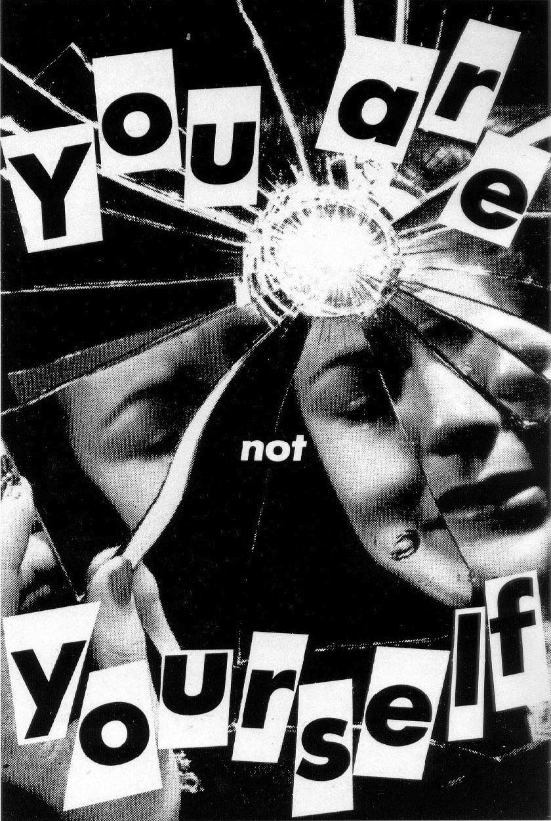

Part IV. “Third Wave” Feminisms
Class 12 (Oct. 1): Postmodern Feminism
Sandra Lee Bartky, 1988, “Foucault, Femininity and the Modernization of Patriarchal Power,” Ch. 3.

Judith Butler, 1990, “Bodily Inscriptions, Performative Subversions,” Gender Trouble: Feminism and the Subversion of Identity, Routledge: 128-141 (focus on 134-141).

Recommended:
Scott, Joan Wallach, 1988, "Deconstructing Equality-Versus-Difference: Or, the Uses of Poststructuralist Theory for Feminism," Feminist Studies 14 (1): 33-50.

Seyla Benhabib, Judith Butler, Drucilla Cornell, and Nancy Fraser, 1995, with an introduction by Linda Nicholson, Feminist Contentions: A Philosophical Exchange, Routledge.

Linda Nicholson, ed., 1990, Feminism/Postmodernism (Thinking Gender), Routledge.

Diana Fuss, 1989, Essentially Speaking, Routledge.

Colette Guillaumin, 1995, Racism, Sexism, Power, and Ideology, Psychology Press.

Allison Weir, 1996, Sacrificial Logics, Routledge.

(Oct. 6): NO CLASS - READING DAY

Class 13 (Oct. 8): Woman and Gender*
Toril Moi, 1999, What is a Woman? And Other Essays, New York: Oxford University Press: 72-83 and 93-99 (Corbett v Corbett).

Iris Marion Young, 2002, “Lived Body vs Gender: Reflections on Social Structure and Subjectivity,” Ratio 15 (4): 410-428.

Recommended:
Joan Scott, 1988, “Gender: A Useful Category of Historical Analysis,” Gender and the Politics of History, Columbia University Press: 28-50 (focus on Part II).

Elizabeth Spelman, 1988, Inessential Woman, Beacon Press.

Denise Riley, 1988, Am I That Name?: Feminism and the Category of “Women” in History, MacMillan.

Judith Butler, 1990, Gender Trouble: Feminism and the Subversion of Identity, Routledge: Ch. 1.

Monique Wittig, 1981, “One is Not Born a Woman,” (SW #15).

Linda Alcoff, 1988, Cultural Feminism Versus Post-Structuralism: The Identity Crisis in Feminist Theory” (SW #20).

Anne Fausto-Sterling, 1993, “Why Five Sexes are Not Enough” The Sciences (March/April).

Judith Butler, 1990, Gender Trouble: Feminism and the Subversion of Identity, Routledge: Ch. 1.

Karen Beckwith, 2005, “A Common Language of Gender?” Politics and Gender 1(1): 128-136.

Mary Hawkesworth, 2006, “Gender as an Analytic Category,” in Feminist Inquiry: From Political Conviction to Methodological Innovation, Rutgers University Press: 145-175.

Class 14 (Oct. 13): Women of Color Feminisms
Audre Lorde, 1984, “The Master’s Tools Will Never Dismantle the Master’s House”

Combahee River Collective, 1977, “A Black Feminist Statement,” (SW #4).
Check out Chirlane McCray, Combahee River Collective member, in New York City politics.

Patricia Hill Collins, 2000 (2nd edition), "The Politics of Black Feminist Thought," in Black Feminist Thought: Knowledge, Consciousness, and the Politics of Empowerment, (SW #14).

Recommended:
Cherrie Moraga and Gloria Anzaldúa, 1981 [1983], This Bridge Called My Back: Writings by Radical Women of Color, Persephone Press [Table Kitchen Press].

Kimberlé Crenshaw, 1997, “Intersectionality and Identity Politics: Learning from Violence Against Women of Color” differences 9 (3): 46-64.

Deborah K. King, 1988, “Multiple Jeopardy, Multiple Consciousness: The Context of a Black Feminist Ideology,” Signs 14 (1): 42-72.

Gloria T. Hull and Patricia Bell Scott eds., 1993, All the Women are White, All the Blacks are Men, But Some of Us are Brave, Feminist Press at CUNY.

bell hooks, 2000, “Black Women Shaping Feminist Theory,” From Margin to Center, South End Press: Ch. 1.

Class 15 (Oct. 15): “Third World” Feminism*
Half the students will read Mohanty, the other half will read Narayan. Everyone reads Mies.

Maria Mies, 1998, “Women Under Colonialism,” Patriarchy and Accumulation on a World Scale: Women in the International Division of Labour, Zed Books, 2nd edition: 90-111.

Chandra Talpade Mohanty, 1988, “Under Western Eyes: Feminist Scholarship and Colonialist Discourses,” in Power, Representation, and Feminist Critique: 51-80.

Uma Narayan, 1997, “Contesting Cultures: ‘Westernization,’ Respect for Cultures, and Third-World Feminists,” in Dislocating Cultures, (SW #23) [Note: the online version is a different excerpt. Use the SW version posted on Collab if you do not own SW.]

Recommended:
Lila Abu-Lughod, 2002, “Do Muslim Women Really Need Saving? Anthropological Reflections on Cultural Relativism and Its Others,” American Anthropological Association 104(3): 783-790.

Valerie Amos and Pratibha Parmar, 1984, "Challenging Imperial Feminism," Feminist Review 17: 3-19.

Hazel V. Carby, 1985, “On the Threshold of Woman’s Ear”: Lynching, Empire, and Sexuality in Black Feminist Theory,” Critical Inquiry 12 (Autumn): 262-277.

Gayatri Spivak, 1988, “Can the Subaltern Speak?” in Cary Nelson and Lawrence Grossberg, eds., Marxism and the Interpretation of Culture, Macmillan.

Trinh T. Minh-ha, 1989, Woman, Native, Other: Writing Postcoloniality and Feminism, Indiana University Press.

Kumkum Sangari, 1989 [1990], Recasting Women: Essays in Colonial History, Kali for Women [Rutgers University Press].

Anne McClintock, 1995, Imperial Leather, Race, Gender, and Sexuality in the Colonial Contest, Routledge.

Oyeronke Oyewumi, 1997, The Invention of Women: Making African Sense of Gender Discourse, University of Minnesota Press: Ch. 2.

Last day to withdraw from a Course: Oct. 20

Class 16 (Oct. 20): Ecofeminism
Karen J. Warren, 1990, “The Power and Promise of Ecological Feminism,” Environmental Ethics 2 (2): 125-146.

Vandana Shiva, 1993, “Reductionism and Regeneration: A Crisis in Science,” in Maria Mies & Vandana Shiva, Ecofeminism, Zed Books: 22-35.

In-class Film Clip: Bill Moyers with Vandana Shiva on the Problem with Genetically Modified Seeds

Film clip: “Mad Max: Fury Road”

Recommended:
Susan Griffin, 1978, Woman and Nature, Harper & Row.

Ynestra King, 1989, “The Ecology of Feminism and the Feminism of Ecology” in Healing the Wounds: The Promise of Ecofeminism, New Society Publishers.

Carolyn Merchant, 1995, Earthcare: Women and the Environment, Routledge.

Vandana Shiva, 1989, “Development, Ecology and Women” in Staying Alive: Women, Ecology and Development, Zed Books (author of many books, most recently: 2005, Earth Democracy: Justice, Sustainability, and Peace, South End Press).

Irene Diamond and Gloria Orenstein, eds., 1990, Reweaving the World: The Emergence of Ecofeminism, Sierra Club Books.

Jytte Nhanenge, 2011, Ecofeminism: Towards Integrating the Concerns of Women, Poor People, and Nature into Development, University Press of America.

Class 17 (Oct. 22): Queer Theory*
Judith Butler, 1993, “Imitation and Gender Insubordination,” (SW #18).

Judith Halberstam, 1998, Female Masculinity, Duke University Press: 1-44.

Recommended:
Michael Foucault, 1990, History of Sexuality, Volume I, An Introduction, Vintage.

Gloria Anzaldúa, 1981 [1983], “La Prieta” in Cherrie Moraga and Gloria Anzaldúa, This Bridge Called My Back: Writings by Radical Women of Color, Persephone [Kitchen Table Press] 2nd edition: 198-209.

Eve Kosofsky Sedgwick, 1990 [2008], Epistemology of the Closet, University of California Press.

Caprica and the Queerness of Sam Adama

Gilbert Herdt, ed. 1996, Third Sex, Third Gender: Beyond Sexual Dimorphism in Culture and History, Zone Books.

Steven Seidman, 1995, “Deconstructing Queer Theory or the Under-Theorization of the Social and the Ethical,” in Linda Nicholson and Steven Seidman eds., Social Postmodernism: Beyond Identity Politics, Cambridge University Press: 116-141.

Michael Warner and Lauren Berlant, 1998, “Sex in Public,” Critical Inquiry 24 (2): 547-566.

Georgia Warnke, 2001, "Inter-sexuality and the categories of Sex," Hypatia, 16 (3):126-137.

Judith Butler, 1993, Bodies that Matter: On the Discursive Limits of Sex, Routledge.

Garatri Gopinath, 2005, Impossible Desires: Queer Diasporas and South Asian Public Cultures, Duke University Press.

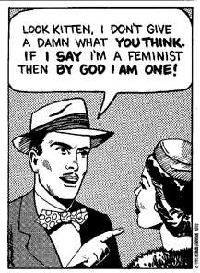

Class 18 (Oct. 27): Masculinity and Men
R. W. Connell, 2005, Masculinities, University of California Press, Ch. 3 and Afterward.

Patricia Hill-Collins, 2004, “Booty Call: Sex, Violence, and Images of Black Masculinity,” Black Sexual Politics: African-Americans, Gender and New Racism. Routledge: Ch 5.

Homework film clip: The Bro Code: How Contemporary Culture Creates Sexist Men (NB: sexual violence briefly depicted).

Recommended:
Tim Carrigan, Bob Connell, and John Lee, 1985, “Toward a New Sociology of Masculinity,” Theory and Society 14 (5): 551-604.

Rachel Adams and David Savran, eds., 2002, The Masculinity Studies Reader,
Blackwell.

Judith Kegan Gardiner, 2002, Masculinity Studies and Feminist Theory, Columbia University Press: 244-268.

bell hooks, 2003, We Real Cool: Black Men and Masculinity, Routledge.

Part V. Contemporary Feminisms
Class 19 (Oct. 29): Contemporary Liberal Feminisms*
Shelley Budgeon, 2015 “Individualized femininity and Feminist Politics of Choice,” Europeean Journal of Women’s Studies: 1-16.

Elizabeth K. Markovits and Susan Bickford, 2014, “Constructing Freedom: Institutional Pathways to Changing the Gender Division of Labor,” Perspectives 2(1): 81-99.

Recommended:
Jennifer Baumgardner and Amy Richards, 2000, Manifesta: Young Women, Feminism, and the Future, Farrar, Straus and Giroux.

Linda Hirshman, 2007, Get to Work…And Get A Life, Before It’s Too Late

R. Claire Snyder-Hall, 2010, “Third-Wave Feminism and the Defense of ‘Choice,’” Symposium: Women's Choices and the Future of Feminism, Perspectives on Politics 8: 255-261.

Nancy J. Hirschmann, 2010, “Choosing Betrayal,” Symposium: Women's Choices and the Future of Feminism, Perspectives on Politics 8: 271-278.

Claire R. Snyder, 2008, “Third Wave Feminism: A New Directions Essay,” Signs 34 (1): 175-96.

Mary Caputi, 2015, Feminism and Power: The Need for Critical Theory, Lexington Books.

Jennet Kirkpatrick, 2010, “Introduction: Selling Out? Solidarity and Choice in the American Feminist Movement,” Symposium: Women's Choices and the Future of Feminism, Perspectives on Politics 8: 241-245.

Michaele L. Ferguson, 2010, “Choice Feminism and the Fear of Politics,” Symposium: Women's Choices and the Future of Feminism, Perspectives on Politics 8: 247-253.

Pamela Stone, 2007, Opting Out? Why Women Really Quit Careers and Head Home, University of California Press.

Lori J. Marso, 2010, “Feminism’s Quest for Common Desires,” Symposium: Women's Choices and the Future of Feminism, Perspectives on Politics 8: 263-269.

Interview with Sheryl Sandberg on “Women’s Media Center Live with Robin Morgan”

Class 20 (Nov. 3): Intersectionality
Cathy Cohen, 1999, The Boundaries of Blackness: AIDS and the Breakdown of Black Politics, University of Chicago Press, Ch. 1.

Patricia Hill-Collins, 2004, Black Sexual Politics: African-Americans, Gender and New Racism, Routledge, Ch. 3.

Homework Film Clip: The Other City

Recommended:
Mary Hawkesworth, 2006, “Intersectionality,” in Feminist Inquiry: From Political Conviction to Methodological Innovation: 207-248.

Mary A. Robertson and Arlene Sgoutas, 2012 “Thinking beyond the Category of Sexual Identity: At the Intersection of Sexuality and Human-Trafficking Policy,” Politics & Gender 8 (3): 421 – 429.

Leslie McCall, 2005, “The Complexity of Intersectionality,” Signs: Journal of Women in Culture and Society 30 (3): 1771–1800.
Rita Kaur Dhamoon, 2011, “Considerations on Mainstreaming Intersectionality,” Political Research Quarterly 64 (1): 230-243.

Nira Yuval-Davis, 2006, “Intersectionality and Feminist Politics.” European Journal of Women’s Studies 13 (3): 193-209.
Special Issue on Intersectionality, 2008, Sex Roles 59 (5-6).

Class 21 (Nov. 5): Transnational Feminism*
Inderpal Grewal and Caren Kaplan, 1994, “Introduction: Transnational Feminist Practices and Questions of Postmodernity,” in Inderpal Grewal and Caren Kaplan, eds., Scattered Hegemonies, University of Minnesota Press: 1-33.

Richa Nagar and Amanda Lock Swarr, 2010, “Introduction: Theorizing Transnational Feminist Praxis,” in Amanda Lock Swarr and Richa Nagar, Critical Transnational Feminist Praxis, SUNY Press: 1-22.

Recommended:
Map Dishonesty

Inderpal Grewal, 2008, “The Transnational in Feminist Research: Concept and Approaches,” Mehrheit Am Rand? 4:189-199.

Nira-Yuval Davis, 2006, “Human/Women’s Rights and Feminist Transversal Politics,” in Myra Marx Ferree and AIli Mari Tripp, eds., Global Feminism: Transnational Women’s Activism, Organizing, and Human Rights, New York University Press: 275-295.

Nancy A. Naples and Manisha Desai, 2002, “The Challenges and Possibilities of Transnational Feminist Praxis,” Routledge: 276-281.

Breny Mendoza, 2002, “Transnational Feminisms in Question,” Feminist Theory 3 (3): 295–314.

Inderpal Grewal and Caren Kaplan, 2001, “Global Identities: Theorizing Transnational Studies of Sexuality,” GLQ: A Journal of Lesbian and Gay Studies 7 (4): 663-679.

Ellen Carol Dubois and Katie Oliviero, 2009, Special issue on circling the globe: International feminism reconsidered, 1910-1975, Women’s Studies International Forum 32 (1): 1-66.

Brooke A. Ackerly and Katy Attanasi, 2009, “Global Feminisms: Theory and Ethics for Studying Gendered Injustice,” New Political Science 31 (4): 543–55.

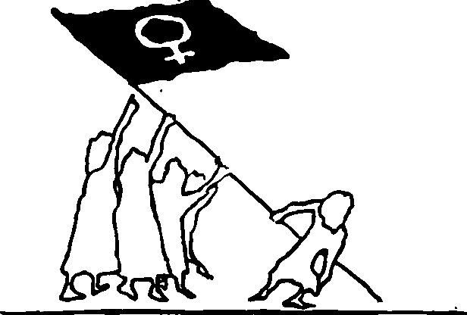

Class 22 (Nov. 10): Contemporary Socialist Feminism
Iris Marion Young, 2003, “The Logic of Masculinist Protection: Reflections on the Current Security State,” in Marilyn Freedman, Women and Citizenship, Oxford Scholarship Online; also posted on Collab.

Elizabeth Bernstein, 2010, “Militarized Humanitarianism Meets Carceral Feminism: The Politics of Sex, Rights, and Freedom in Contemporary Antitrafficking Campaigns,” Signs 36 (1): 45-71.

In-class film clips: “Taken” and “The Whistleblower”

Recommended:
Elisabeth Anker, 2012, “Feminist Theory and the Failures of Post-9/11 Freedom,” Politics & Gender 8 (2): 207-216.

Nancy Fraser, 2009, “Feminism, Capitalism and the Cunning of History,” New Left Review 56 (March/April): 97-117.

Mary Hawkesworth, 2012, Political Worlds of Women, Westview Press.

Lisa Duggan, 2004, The Twilight of Equality: Neoliberalism, Cultural Politics and the Attack on Democracy, Beacon Press.

For articles by socialist feminist theorists on a wide array of global issues, from microcredit to population flows, see Signs: A Journal of Women in Culture and Society, especially volumes published in the past 6 years.

Class 23 (Nov. 12): Contemporary Queer Theory*
Anne Fausto-Sterling, 2000, “Should There Be Only Two Sexes?” in Sexing the Body, Basic Books: Ch. 4.

Heath Fogg Davis, 2014, “Sex-Classification Policies as Transgender Discrimination: An Intersectional Critique,” Perspectives 12 (1): 45-60.

Recommended:
Judith Halberstam, 2005, In a Queer Time and Place: Transgender Bodies, Subcultural Lives, New York University Press.

Kristen Schilt, 2009, “Doing Gender, Doing Heteronormativity,” Gender & Society 23 (4): 440-464.

Riki Wilchins, 2002, “A Certain Kind of Freedom: Power and the Truth of Bodies,” in Genderqueer: Voices from Beyond the Sexual Binary, Alyson Books: 21-63.

Julia Serano, 2009, “Trans Woman Manifesto” 547-551.

Mary Anne Case, “Why Not Abolish the Laws of Urinary Segregation?”

Buz Bissinger, 2015, “Caitlyn Jenner: The Full Story,” Vanity Fair July.

“I am Cait” Reality TV Show

“Transparent,” TV series

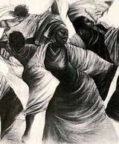

Class 24 (Nov. 17): Final Research Project
Brooke Ackerly and Jacqui True, 2010, Doing Feminist Research in Political Science and Social Science, Ch. 1 and 2.

Shaun McNiff, 2008, “Art-based Research,” in J. Gary Knowles, Ardra L. Cole, eds., Handbook of the Arts in Qualitative Research: 29-40.

WE WILL NOT MEET IN CLASS TODAY.

You are welcome to attend the job talk by Cynthia Daniels, “Informed or Misinformed Consent? Abortion Politics in the States,” Gibson Hall, Room 296, 12:00-1:30.

YOU MAY DO A POSTING FOR THE ASSIGNED READINGS. WE WILL DISCUSS THEM ON NOV. 19 AND NOV. 24.

Class 25 (Nov. 19): Feminist Research
Brooke Ackerly and Jacqui True, 2010, Doing Feminist Research in Political Science and Social Science, Ch. 3 and 4.

Chris Sullivan, “Writing an Artist Proposal,” The Career + Co-op Center, School of the Art Institute of Chicago.

Bess Sadler and Chris Bourg, 2015, “Feminism and the Future of Library Discovery,” code{4}lib Journal, Issue 28.

Guest speakers: Ms. Purdom Lindblad, Librarian for WGS and Maggie Nunley

At the end of class, students will work in small groups to develop their individual research topics and strategies for finding sources.

Nov. 23: Office hours from 1:30-4:30

Class 26 (Nov. 24): Research Proposals Due Tomorrow on Collab by 12:30; Office hours from 1:45-3
Wrap up discussion of Ackerly and True, Sullivan, McNiff and final research project assignment and rubric.

Note: Your research proposal needs a question that you hope to answer. You can’t have an answer/creative product until you do the research and complete the project. Make sure that you don’t know the answer to your question but that you have an idea about how you will go about finding the answer to it and that you explain this in the proposal.

A good research question is contestable, supportable and specific.

*Thanksgiving Break: November 25-November 29*

Class 27 (Dec. 1): Writing Well
Regardless of your topic and medium, most students will turn in some writing with their project. Read the discussion about how to do a research paper for strategies on how to narrow your research project topic and more. For general tips browse this site; and check out this last one for strategies on how to make a convincing argument.

Guest Speaker: Anne Llewellyn, UVa Writing Center: aml3hx@virginia.edu

In-class exercise: bring a hard copy of your research proposal to class.

Class 28 (Dec. 3): Outlining and Evidence
Read the discussion about how to do an outline and browse this site for more writing tips. Click here for an explanation and illustration of how to make an outline for a research paper and here for a parody of Mary Kate Olson on the difference between reasons and evidence, and here for a clip from the TV show “Mythbusters” on evidence.

Mary Hawkesworth, 2006, “Evidence,” Feminist Inquiry: From Political Conviction to Methodological Innovation, Rutgers University Press: 98-117.

Students will work in writing groups to develop the outline for their research projects and/or to do research. Bring a copy of your revised research proposal to class.

Class 29 (Dec. 8): Student Presentations
Groups of 6 will make 8 minute presentations about a shared research project theme, e.g., insights gained from discussing one another’s projects, how the group helped one person overcome a research challenge, Q&A for the class related to course content taken from the group member’s research project, each group member sharing a surprising research finding, etc. Do not take turns presenting your own work.

The purpose of this exercise is to have students help each other improve their projects and to give everyone in the class an opportunity to learn what others are doing for the final project and offer feedback.

Dec. 12: Research Project due at 2pm as an attached file on Collab
Writing is thinking, and good writing require numerous drafts. For general suggestions on how to revise your writing see “Rewriting or Revising.”

