School of Continuing Instructor: Noel Montesa, CPA
and Professional Studies Email: nem6a@Virginia.edu

ACCT 2020: Fundamentals of Accounting Part 2
Spring 2016
DATE | CHAPTER | ASSIGNMENTS (Connect)
WK 1  Jan. 25, 2016 | Chapter 12  Accounting for Partnerships | Homework: Exercise 12-1, 12-3, 12-4, 12-6, 12-7, 12-8, 12-9
WK 2  Feb 1, 2016 | Chapter 13  Accounting for Corporations | Homework Exercise: 13-1, 13-2, 13-3, 13-4, 13-6, 13-7, 13-8, 13-9,  13-10, 13-12, 13-14
WK 3  Feb 8, 2016 | Chapter 14  Long Term Liabilities | Homework Exercise: 14-1, 14-2, 14-4, 14-11, 14-12, 14-13, 14-14,  14-15, 14-16
WK 4  Feb 15, 2016 | Chapter 15  Investments and International Operations  ONLINE QUIZ 1: Chp 12-14 due 6 pm | Homework Exercise: 15-1, 15-2, 15-3, 15-5, 15-6, 15-7, 15-9, 15-10,  15-12
WK5  Feb 22, 2016 | Chapter 16  Reporting the Statement of Cash Flows | Homework Exercise: 16-2, 16-3, 16-6, 16-8, 16-9, 16-13  Problem 16-1A
WK6  Feb 29, 2016 | Chapter 17  Analysis of Financial Statements | Homework Exercise: 17-1, 17-8, 17-11, 17-12  Problem 17-5A
WK7  Mar 7, 2016 | Chapter 18  Managerial Accounting Concepts  MID-TERM DUE Chapters 12-16 | Homework Exercise: 18-1, 18-3, 18-5, 18-8, 18-10, 18-11, 18-12
WK8  Mar 14, 2016 | Chapters 19 and 20  Job order and Process Cost Accounting | Homework Exercise: 19-1, 19-3, 19-5, 19-6, 19-7: 20-1, 20-2, 20-5, 20-6, 20-7, 20-8, 20-9, 2010
WK9  Mar 21, 2016 | Chapter 21, Cost Volume Profit Analysis  ONLINE QUIZ 2: chp 17-19 due 6 pm | Homework Exercise: 21-1, 21-2, 21-3, 21-7, 21-10
WK10  Mar 28, 2016 | Chapter 22  Master Budgets and Planning | Homework Exercise: 22-3, 22-7, 22-8, 22-9, 22-11, 22-14
WK11  April 4, 2016 | Chapter 23  Flexible Budget and Standard Cost | Homework Exercise: 23-2, 23-3, 23-4, 23-6
WK12  April 11, 2016 | Chapter 24  Performance Measure and Responsibility Accounting  ONLINE QUIZ 3: chp 20-23 due 6pm | Homework Exercise: 24-1, 24-2, 24-5, 24-6, 24-7, 24-8, 24-10  (NO CLASS April 18, 2016)
WK13  April 25, 2016 | Chapter 25  Capital Budgeting and Managerial Decisions | Homework Exercise: 25-1, 25-4, 25-7, 25-8, 25-9, 25-10, 25-11, 25-12
WK14  May 2, 2016 | FINAL EXAM DUE  NO SESSION

COURSE GRADING/ASSESSMENT:
Homework completion (Using Connect): 9%
Online quizzes (Using Collab) 39%
Mid-Term and Final Exams 52%
TOTAL: 100%

Required Text (or eBOOK available through Connect – same used in prerequisite course ACCT 2010):
Fundamental Accounting Principles, (chapter 12-25), 22th edition. Larson, Wild and Chiappetta (McGraw-Hill/Irwin, New York, NY).

COURSE DESCRIPTION: Continuation of ACCT 2010. Approximately one third of the course deals with additional financial accounting topics, emphasizing managerial considerations and financial analysis. Cost accumulation, allocation, and product cost methods are studied in a manufacturing setting. Matters such as evaluation of performance planning, cost behavior, and special decisions are emphasized. Prerequisite: ACCT 2010. No class April 18, 2016.

Syllabus & Class Overview Template
Required Components

General Class Information
Instructor Name and Contact Information: Noel Montesa, CPA
nem6a@virginia.edu

Subject Area and Catalog Number: ACCT 2020
Year and Term: Spring 2016 (online synchronous)
Class Title: Introductory Accounting II
Level: Undergraduate
Credit Type: 3.0 credits.

Class Description:
Continuation of ACCT 2010. Approximately one third of the course deals with additional financial accounting topics, emphasizing managerial considerations and financial analysis. Cost accumulation, allocation, and product cost methods are studied in a manufacturing setting. Matters such as evaluation of performance planning, cost behavior, and special decisions are emphasized. Prerequisite: ACCT 2010.

Required Text (ISBN 978-0-07-786227-5, 22nd edition):
Fundamental Accounting Principles, (chapter 12-25), 22nd edition. Larson, Wild and Chiappetta (McGraw-Hill/Irwin, New York, NY).

Learning Outcomes:
This course will focus on external reporting requirements as well as internal reporting methods, cost accumulation and allocation methods, budgets and managerial making tools. Chapters 12 through 25 will be covered.
- Comprehend accounting for Partnerships and Corporations.
- Comprehend the use of Bonds for capitalization of the organization.
- Write up Cash Flow Statements and their impact on the financial statements.
- Comprehend job and process costing, analyze cost behaviors and formulate assessments based on prescribed metrics.
- Analyze and formulate budget and the use of flexible and standard budget.
- Comprehend the use of forecasting tools.
- Fully understand the time value of money.
- Calculate metrics such as IRR, payback rate and other metrics to assess business strategy and potential future outcome.
- Preparation to fully understand subject matters in Intermediate Accounting.

Delivery Mode Expectations (Classroom/Internet and Web-based classes, specify any live (synchronous) meetings, dates, times, and location of delivery). Class will meet on Monday nights from 6:30pm to 9:45pm synchronous. Class start date January 25, and class end date May 2, 2016.

Required Technical Resources and Technical Components:
(Recommended, not required additional resources) Fundamental Accounting Principles, student study guide.
Textbook Website – www.mhhe.com/wildfap21e

Class Specific Information
Class Instruction and Activities:
This class will meet once a week on Monday nights Online using Collab. Class attendance is required.

Class Requirements:
Prior to each class, students are expected to have completed the assigned reading. Lecture templates (available in UVA Collab) will be available to you at each class to supplement your notes and allow for a more engaging lecture. Partial assigned problems will be reviewed in the following session. Since this class is quantitative in nature, preparation is always important. Also, lectures may not cover every topic in detail.
Evaluation Standards and Assessments:
There will be 3 quizzes and 2 exams. Your final grade will be computed based on the following:
Three quizzes (13 points each) 39 points
Two exams (26 points each) 52 points
Participation (online) 9 points
Total 100 points

9 percent of your grade is based on homework completion and quality of participation. Participation involves responding to questions, and responding to requests for recommended solutions to exercises and problems. Your answers do not have to be correct however, they should indicate that you are paying attention, have read the material, and have made an attempt to do the exercises and problems. You are encouraged to ask questions on any material that you do not understand and/or for which you desire additional information. Your participation is not intended to put you “on the spot” or place you in an embarrassing position. The only purpose is to assist you learning in a respectful and courteous fashion.
Communication & Student Response Time:
Assignments:
See class schedule for weekly homework assignments.
Resources:
Required textbook. Handouts related to the week’s session will be provided in class. Solutions for assigned homework are provided directly to the student by email.
Connect Online

What You Need
You will be required to have materials from McGraw-Hill Education which include the textbook content and Connect (which includes LearnSmart, your adaptive online study tool, and SmartBook, your adaptive ebook).

Where to Get It
- Bookstore: Your bookstore has a package which includes the print book and the Connect online access code (you will need this code to access the online study modules and materials). To register, follow the steps below.
- Online - All DIGITAL: You can purchase Connect (no print book, but includes the complete ebook and access to all course content) directly from the course website. To register, follow the steps below.

How to Register for Connect Via Blackboard
- To get started, click the first Connect assignment in your Blackboard course.
- Click the “Register Now” Button.
- Enter your email address.
  - If you already have a McGraw-Hill account you will be prompted for your password.
  - If you do not have a McGraw-Hill account you will be asked to create one.
- To access Connect (see example):
  - If you already have a registration code (for example, included in the print package from the bookstore), enter it in the “Have a registration code?” section.
  - If you do not have an access code, select “Buy Online” (valid credit card required).
  - If you wish to purchase at a later time, you may begin a 14-day Courtesy Access period at this time. You will be prompted to upgrade to full Connect access before your courtesy access period expires. You must purchase full Connect access in order to maintain access to your course assignments and materials
- Complete the registration form, and click “Submit”
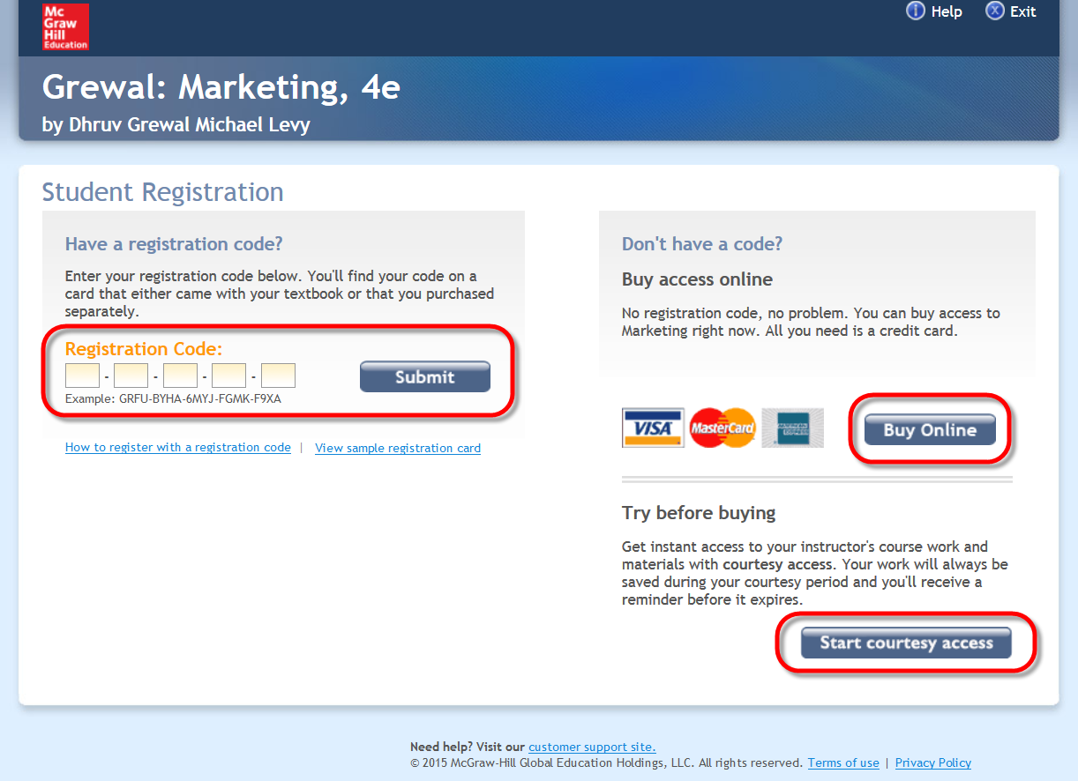
FAQs & Tutorials
Visit the Connect Student Success Academy for online FAQs and tutorials:
http://www.connectstudentsuccess.com/
Technical Support
If you need Technical Support (forgotten password, wrong code, etc.)
please contact the McGraw-Hill Education Customer Experience Group (CXG) at:
(800) 331-5094
www.mhhe.com/support
(Please be sure to get your case number for future reference if you call the CXG line.)

