Dr. Carrie Douglass cbd7eb@virginia.edu
Department of Anthropology/ University of Virginia Office: Brooks Hall B003
ANTH 4591 Office Hrs. T 1:30-3:00 and
TuTh 11:00-12:15 TR 5:00
CAB 287 Phone: 982-2993

SENIOR SEMINAR

ANIMALS: GOOD TO THINK
Fall 2016

Course Description:
Animals: Good to Think will be a seminar on the anthropology of human cultural relations with animals. It is inspired in part by the recent research and theory in animal studies. The seminar will emphasize only a few of many possible themes, such as animals as symbol, animals as spectacle and sport, animals as domesticates, “pets” and food, and animals as scientific object. We will especially emphasize horses.

Required Texts:

Cassidy, R. The Sport of Kings: Kinship, Class and Thoroughbred Breeding in Newmarket
Kalof, L. The Animal Reader (2007)
Lawrence, E.A. Rodeo: An Anthropologist Looks at the Wild and the Tame (1982)
COLLAB: many articles
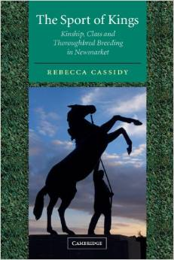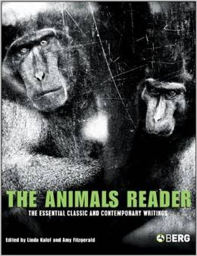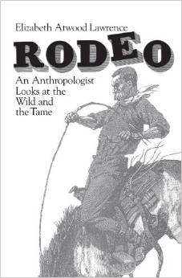

Aims of the Course:
- To be aware of some of the many topics researched and analyzed in Animal Studies
- To be aware of some of the traditional, as well as new, approaches to animals in the discipline of Anthropology. We will consider “animals” in all four fields of Anthropology. The majority of the class will cover socio-cultural anthropological topics.
- To read some of the classic anthropological literature on and about “animals.”
- By reading texts, to consider various way people use animals to think about and tell stories about themselves.
- To participate and be able to lead group discussion (seminar).
- To imagine and carry out a short ethnographic project on “animals” during the course.
- To write a significant paper, with thesis, on your ethnographic project.

Grading and Testing:

It is necessary to read the two books (Cassidy, Lawrence,) and many of the articles in the Animal Reader. Other articles (found on Collab and starred in the syllabus) are also required. (If the article is not starred, it is recommended). Starting week #1, informal weekly reading response papers (no more than 500 words) will be due on Fridays by 5pm (in the Collab Drop Box)(this gets me familiar with your writing and analytical abilities). You will turn in summaries of the two books (about 750 words; Cassidy due Oct. 18, Lawrence due Nov.1). Your big project in this “capstone” course will be your thesis paper. In week #9 your paper topics are due. In week #12 the Introduction and the Thesis Statement is due for your paper. I will correct them, comment, and hand them back after Thanksgiving. Student groups will be responsible for leading discussion for each of the two books (Oct. 20, Nov. 1) and four other readings (Oct. 25, Oct. 27, Nov. 15, Nov. 29). Moreover, you are expected in a seminar to comment, ask questions, elicit opinions and participate everyday in class. I record your participation daily.

A formal oral presentation of your paper topic will be made toward the end of the course, during class time or outside of class time (Dec. 1, and Dec. 6, and perhaps Dec. 12 during our final exam time). Presentations, accompanied by a Power Point, will be about 10-15 minutes. For the evening session pizza will be served. These are required sessions.

Your grades are based on your class participation (and your role as discussion leader and your presentations), the weekly reading responses and book summaries you hand in, and your paper.

Participation, Presentations, discussion leader = 20%
Weekly reading responses = 20%
Book summaries = 20%
Paper = _ 40%_
100%

Attendance:

Attendance in class is essential. For each absence over two your final grade may be lowered one letter. Participation and discussion in class is required (I take notes everyday). All work must be handed in for you to get a final grade. Of course, we all abide by the Honor Code.

ANIMALS: GOOD TO THINK

Syllabus
Fall 2016

TOPICS AND READINGS

week

#1 Aug. 23, Tues. - INTRODUCTION: Course requirements, Course format, etc.
What is an animal?
Teaching the Animal—Across Disciplines

Aug. 25, Thur. - 4 Fields of Anthropology:
Physical/Biological: (Primates, shared natures and cultures)
AR: Ch. 13, “Orangutan Cultures”*
De Waal, “Parable of the Good Simian”* (on Collab)
B. King, “Chimpanzees” (on Collab)*
Ape Culture file (on Collab)*
Lab Ape file* (on Collab)*
Film: Chimpanzee

#2 Will meet on Aug. 31, Wed. from 6:30-7:45 in Brooks Hall Commons
Aug. 30, Tues. - Physical/Biological cont. The mirror test.
“Our Animal Natures” (on Collab)*
“ Vets and Physicians” (on Collab)*
B. King, “Sea of Emotion” (on Collab)*
B. King, “Elephant Bones” (on Collab)*
“Elephants: large, Long-Living and Less Prone to Cancer” (on Collab)
Dolphin file (on Collab)*
Do Animals have Souls? ppt.
Film: Blackfish

Sept. 1, Thurs. - Archaeology: Hunters vs. Farmers, cave art, ppt.
AR: Ch. 14, “The Hunter-Gather Prehistory”*
AR: Ch. 15, “Animal Planet”*
“African Tribesmen Can Talk Birds into Helping Them Find Honey” (on Collab)

#3 Sept. 6, Tues. - Archaeology cont.
Domestication:
Ingold, “From Trust to Domination” (on Collab) *
DeMello, “Present and Future of Animal Domestication (on Collab)

Sept 8, Thurs. - Archaeology cont.
Domestication cont.
Russell , “Domestication of Anthropology*
“Goods from the Grave” (on Collab)*
“Altai Mountains” (on Collab)
“Where the Wild Things Are” ppt.

#4 Sept. 13, Tues. - Linguistic: Smith, “Language and the Frontiers” (on Collab)* Aymara speakers ppt.
Wade, “Family Tree of Languages…” (on Collab)*
“From the Mouths of Babes and Birds” (on Collab)*
Language file (on Collab)-various
http://www.koko.org/index.php
http://www.youtube.com/watch?v=2Dhc2zePJFE

Sept. 15, Thurs.- Sociocultural: Topics-
“Western” Understanding of Animals vs. Perspectivism
AR: Ch. 1, “The History of Animals”* Aristotle
AR: Ch. 3, “In Defense of Slavery”* Spiegel
AR: Ch. 8, “An Apology for…”*
M. Montaigne
AR: Ch. 9, “From the Letters of…”* Descartes
AR: Ch. 4, “Animal Liberation”*
P. Singer

de Castro, “Cosmological Deixis” (on Collab)*
Animal Rights file (on Collab):

#5 Sept. 20, Tues. - Totemism: At the Beginning of Anthropology,
Nature-Culture

Sept. 22, Thurs.- Animals as Food: Good to Eat
Food Categories
AR: Ch. 18, “Brave New Farm”* Mason & Finelli
AR: Ch. 19, “Sexual Politics of Meat”* Adams
Singer, Peter, “Open the Cages” (on Collab)
Slaughter House file (on Collab)- various articles*
Taboos: Leach, “Animal Categories and Verbal Abuse”(on Collab)*

#6 Sept. 27, Tues. - Horse meat file (on Collab)- various articles*

Two different explanations of the pork taboo:
1. M. Harris, “Mother Cow & Pig Lovers” (on Collab)* ppt.
2. Douglas, “Leviticus.”* (on Collab)

Sept. 29, Thurs. - To Think With (Food for Thought)
AR: Ch. 27, “Totemic Illusion”*
Levi-Strauss
Levi-Strauss, “Totem & Caste” & “Individual as Species”* (on Collab)
Campbell, “Kinsmen” & “of Sheep and Shepherds” (on Collab)*
Blok, “Rams & Billygoats” (on Collab)*ppt

#7 Oct. 4, Tues. - FALL BREAK


Oct. 6, Thurs. - “Pets”--Dogs and cats
Companion Animals, partner animals
Breeds: Thoroughbred horses, first
Ritvo, “Emergence of Modern Pet Keeping” (on Collab)
AR: Ch. 16, “Animal Pets”* Yi-Fu Tuan
AR: Ch. 35, “Cyborgs to Companion Species”* Haraway

#8 Oct. 11, Tues. - Grimm, David, “The Road Ahead,” Ch. 12 in Citizen Canine (on Collab)*
Savishinsky, “The Hare and their Dogs”* (on Collab) Pets as Children
Pet file (on Collab)-various articles*
Shir-Vertesh, Dafna, “Felxible Personhood: Loving Animals as Family Members in Israel” (on Collab)

Oct. 13, Thurs. - Zoos
AR: Ch. 24, “Zoo Spectatorship”* Malamud
AR: Ch. 26, “Why Look at Animals”* Berger
Hochade, “Darwin in the Monkey Cage” (on Collab)
Rothfels, “Immersed with Animals”
“Do Gorillas EvenBelong in Zoos?” (on Collab)
Zoo & Circus file (on Collab)- various articles *

#9 Oct. 18, Tues. - Sport of Kings Turn in summary
***PAPER TOPICS DUE*** Hunting and Poaching
AR: Ch. 25, “Hunting and Humanity…”* Cartmill
Poaching Endangered Species file (on Collab)- various articles *

Oct. 20, Thurs. HORSES ppt. and film clip

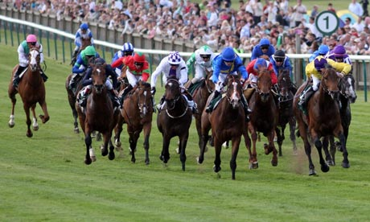

Sport of Kings discussion-
Kinship
AR: Ch. 34, “Dolly’s Body:…”*
Racing Horses File (on Collab)- various articles

#10 Oct. 25, Tues.. -

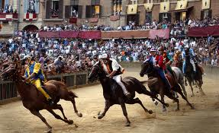

Dundes: “Palio” & “Palio as Metaphor” (on Collab)*
Nationalism
Borneman, “Race, Ethnicity, Species, Breed” (on Collab)* ppt.
Landry, “Learning to Ride in Early Modern Britain”(on Collab)*ppt
Lange , Ch. 3 “Purity, Nobility, Beauty and Performance” *(on Collab)
Arabian horse file: (on Collab)
Landry, “The Bloody-Shouldered Arabian” (in file on Collab)
“Arabian Horses in Turkey” (in file on Collab)
Cassidy, “Turf Wars” (in file on Collab)
Glanz and Nazaal, “For Palestinians, Raising Arabian Horses is the ‘Hobby of the Poor’”(on Collab)
Oct. 27, Thurs. -
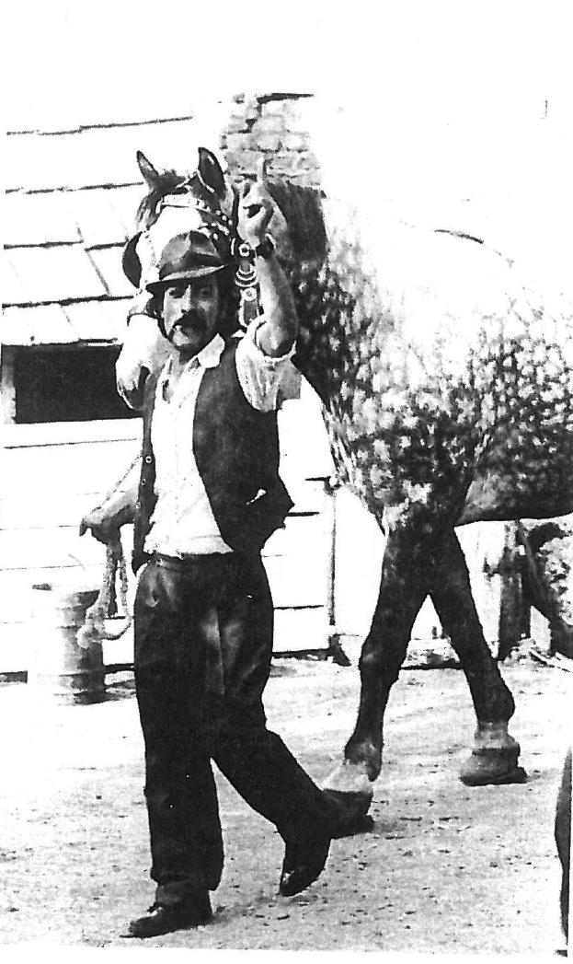
Stewart: “Time of the Gypsies” (on Collab)*
Hurn, “What’s Love Got to Do with It?”*
Douglass, “Thomas Jefferson, Equine Culture and Names” (on Collab)* ppt.

#11 Nov. 1, Tues. -
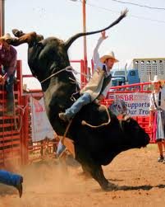
Rodeo–An Anthropologist Looks at the Wild and the Tame,
Turn in summary and discussion

Nov. 3, Thurs. - Wolves
Wolves file (on Collab)-various articles*
Lindquist, “The Wolf, the Saami, and the Urban Shaman”* (in file)
Marvin, “Wolves in Sheep’s (and Others’) Clothing”* (in file)
“A Natural Cure for Lyme Disease”

Mustangs
Wild Horses file (on Collab)-various articles & video clip

#12 Nov. 8, Tues. - INTRO AND THESIS STATEMENT DUE FOR PAPER***

. - Foxhunting

Foxhunting file (on Collab)

Nov. 10, Thurs Fighting with Animals and Betting: Dog fights, fish fights, cock fights)
AR: Ch. 23, “Dogfighting”* Evans, Kalich & Forsyth
Geertz, “Deep Play” (on Collab)* ppt.

#13 Nov. 15, Tues. - 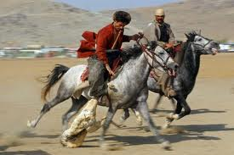
Buzkashi discussion- Power (on Collab)
Game, “Riding: Embodying the Centaur”* (on Collab)
Horses file I (on Collab*)- various articles

Nov. 17, Thurs.- Bulls:

****Film: Our God, the Condor *****

#14 Nov. 22, Tues. - The Nuer
Evans-Pritchard, “Interest in Cattle” and “The Sacrificial Role of Cattle” * (on Collab)
FILM CLIP: http://www.youtube.com/watch?feature=player_embedded&v=J0VBnrIkAtA

Nov. 24, Thurs. - THANKSGIVING VACATION
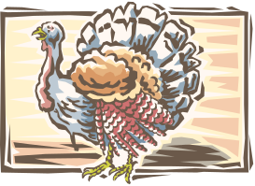

#15 Nov. 29, Tues. – Two different Explanations of the Spanish Bullfight:
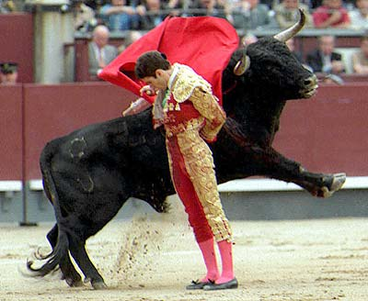
1. Douglass, “Toro muerto, vaca es.”*
(on Collab)

2. AR: Ch. 22, “On Being Human the Bullfight”* Marvin

Dec. 1, Thurs. - Presentations

#16 Dec. 6, Tues. - Presentations
Presentations (cont): 6:00 pm- 9:00 pm
Brooks Hall Commons

FINAL EXAMS: December 8-16, 2016

December 12, 2015 Final Paper/thesis due: 12noon

The starred readings are required. The rest are recommended.

Animal Studies journals:

Society and Animals 1999--
Journal for Critical Animal Studies 2007---
Humanimalia 2009—
Anthrozoös 2005--

