University of Virginia
Women, Gender & Sexuality
Spring 2017

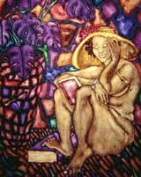

Denise Walsh WGS 3810
Gibson Hall 454 NCH 383
Office Hours: 5:30-6:30 T/Th T/Th 4:00-5:15
denise@virginia.edu

Feminist Theory

This course provides an overview of the historical roots and contemporary developments in feminist theory. We analyze a range of feminist theories, including liberal, Marxist, radical, and postmodern feminism. The course explores how feminist theory applies to a number of themes, including the body, sexuality, imperialism, globalization, and transnationalism. Throughout the course we address race, class, national, and cultural differences in feminist theory.

One of the most significant contributions of feminist theory has been to critically investigate how structures of power oppress, dominate, and exploit “others,” with a focus on women. Through the assigned readings and class discussions, students will learn how to use feminist tools from different traditions to analyze these multiple and intersecting forms of injustice.

The objectives of this course are 1) to provide an overview of feminist theory; 2) to examine competing foundations, arguments, and positions among feminist theories; 3) to develop the analytical skills needed to critically evaluate the assumptions, arguments, and debates among theorists; and 4) to apply these skills in a final research project.

Course Requirements
*A previous course in Women, Gender and Sexuality is strongly recommended.

Participation (20%)
Student attendance, preparation, and active participation in class are required. Come to class with questions. If you are shy find a way to demonstrate to the instructor your engagement with the material. Do not come to class late and do not leave early.

Presentation (15%)
In teams of 2, students will sign up for 10-minute presentations during one class session. Class sessions with discussion leaders are designated with an * on the syllabus. Students should meet beforehand to discuss the readings and plan content. Do not divide up the readings. All student presenters should be familiar with all of the assigned material for the session. A conversation between presenters should occur. Assume everyone has done the reading.

Be aware that the instructor may comment, ask questions, or otherwise intervene during the presentation.

Presentation requirements:
- Introduce the day’s topic with some historical or other relevant background on a slide.
- Present the key question of each reading on a slide: 2 sentences maximum per reading. Take the time to discuss this slide so your audience can copy down the information and think about it.
- Present each author’s claim on a slide: 2 sentences maximum per reading. Take the time to discuss this slide so your audience can copy down the information and think about it.
- Discuss 2 pieces of evidence or arguments that you think best support the claim. Don’t read quotes or long pages of notes; instead, explain the ideas in your own words.
- The instructor will stop any presentation that goes beyond 10 minutes (excluding questions and comments from the class).
- In addition to the 10-minute presentation, students will design a 5-8 minute class activity, e.g., a mini debate, a film clip, small group activity. Be sure to explain the purpose of the activity and its key points. Students must not do the same type of activity that the previous presenters used. Variety keeps our attention. Presenters who do not include an activity fail the assignment.
- Name your powerpoint by the class number, e.g., Class5.ppt, and post it before class on Collab >Discussion and Private Messages>Worksite Discussions>Powerpoint Presentations>Post Reply.

Presenters are not expected to be experts on the material. Instead of answers to the questions outlined above, they also may pose suggested answers to the class and invite discussion. The goal is not to be right but to get the class thinking in a useful direction.

Discussion Postings (30%)
Each student will post an entry on Collab 10 times during the semester. Posts should be 550-600 words, address themes from all the assigned readings for that day, and present your views on issues raised by the authors. Students must engage with the comments of those who posted before them and raise a question for further discussion. Students may summarize concepts, arguments, or debates, although the objective should be to raise questions and take a critical position. Challenge a point, respond to a question, explain why your position is different, ask others what they think about a specific concept, argument, etc. Writing style matters. Be clear, concise, and respectful when disagreeing with others. This is classroom discussion online, not the blogosphere.

Postings are due before class. No late submissions will be accepted. It is your responsibility to make sure that you post 10 times by April 18. No posts will be accepted after April 18. Please note: Collab does not count your posts correctly. You must count them manually. Students are responsible for ensuring completion of all 10 posts. Students may not post on readings for which they are serving as discussion leaders. The instructor will randomly select two of each student’s completed posts to grade: one prior to mid-term and another after midterm.

To post, go to Collab >Discussion and Private Messages> (Topic for that class session)>New Topic (if you are the first to post for that class session; name it whatever you like)>Post Reply (if you are not the first to post for that session, enter your response by “Post Reply” to the most recent post in the thread). Students should not post for class sessions for which they are presenting. Note: All posts should be in one thread. Do not start a separate thread.

Research Proposal (5%)
Proposals should have a one to two sentence question at the top of the page. Do not ask a question that you know the answer to before you do research. If you already know the answer, there is no point in doing research. Instead, ask a question that is puzzling to you so that you will learn something new. The proposal should also include two paragraphs describing how your question relates to feminist theory, the feminist theorists you will draw on to answer your question, how you will apply Ackerly and True’s feminist research ethic, and how you will collect your data, e.g., 10 open-ended interviews of UVA students on the basketball team, analyze what Judith Butler has written about boundary policing and what her critics say about this concept, etc.

The proposal must also have a correctly formatted bibliography with 3-5 outside sources plus several relevant course readings. Students will do additional activities related to the research project as detailed on the course outline.

Final Research Project (30%)
Students are required to conduct independent research for this project and to use outside sources. Students are expected to include a minimum of 5 outside sources in addition to relevant course readings. Projects might compare two feminist traditions (e.g., socialist versus transnational feminism), apply a feminist theory to a particular topic (e.g., abortion, the media, poverty), investigate one feminist theorist analyzing her work on a specific theme (e.g., MacKinnon and pornography), explore how a particular feminist theory is relevant to the student’s life and experience (e.g., Cathy Cohen and Black Lives Matter), etc.

All projects must be analytical, not merely descriptive. Descriptive projects answer the questions “what?” “when?” “who?” Analytical projects answer the question “why?” Use the feminist theorists and ideas we discuss in class. For example, a student might compare how a postmodern feminist approach to media representation of women’s and men’s basketball teams at UVA differs from a Black feminist approach. This would require doing research on postmodern and Black feminism, the basketball teams, and their media representation. Projects must apply and analyze feminist theory; projects that do not do this fail the assignment.

Do not turn in a project that offers a list of facts, people, events, or even ideas. Instead, focus on asking an interesting question that is narrow enough for you to answer in 10-12 pages or a comparably sized project product, and go as deeply as you can into that topic.

Research papers should be double-spaced, in 12 font, 10-12 pages, spell-checked, and include page numbers and a title. Citations and bibliography must consistently follow an established format of the student’s choice. Proof read all written work. Complex ideas are best conveyed through simple language. Proper grammar, spelling, and writing style convey professionalism and excellence. Sign the honor code. Consult the instructor during office hours for guidelines on creative research projects.

Extra Credit
Students may attend one extra credit event during the semester. If a student thinks an event is course related and would like to attend for extra credit, confirm with the instructor first. If the event is a talk, students should write a one page, single-spaced report of what they learned, and include the question that they asked at the talk and the speaker's response. The write-up must be turned in via email to the instructor within two weeks of the event. It will count for up to 5 bonus points, to be added to one of the student’s posting grades.

Guidelines for readings and assignments
Ask questions:
1. What is the question the author asks in the article? That is, what is the core problem that the author addresses?
2. What is the author’s claim? (How does s/he answer the question in #1?)
3. What evidence does the author present to support her/his claim? What does this evidence tell us? Why is it important for the argument? Evidence is not the same thing as an assertion. For example, Young (2003, 5) states, “Central to the logic of masculinist protection is the subordinate relations of those in the protected position.” This is an assertion, not evidence. In theory, evidence is often offered as an example: “The head of the household should decide what measures are necessary for the security of the people and property, and he gives the orders that they must follow if they and their relations are to remain safe” (6). The reader must decide if the evidence is sufficiently compelling to support the assertion, or not.
4. What is your evaluation of the article? Are you convinced? What questions or criticisms does the author’s argument or use of evidence raise in your mind? To answer these questions, students must assess the evidence offered to support the claim.
5. If there are problems or weaknesses, what constructive solution might you offer for resolving the issue or strengthening the argument? Instead of attacking the argument first, instead, think about what evidence you would need to see for the claim to be convincing. Perhaps that evidence exists, and the author failed to use it. Perhaps it does not. If it does not, then pointing this out is a good way to disprove the author’s claim.

Guidelines for Class Participation
Everyone in this course will feel uncomfortable and challenged at times as many of our readings address controversial themes, such as misogyny, racism, and sexual assault. The readings are not on the syllabus to affirm your views, make you feel safe, or because the instructor agrees with them, but because they have had significant influence on feminist thought and contain ideas worthy of intellectual deliberation.
If a reading or someone in the course makes a comment that offends you, remember that we are all learning and do your best to read/listen with respect. As that person is trying to develop an idea, focus most on the idea and honestly think about it. Be careful not to reject all of someone’s ideas because one or even several things they write or say offend you. Instead, embrace this moment, as it is an opportunity to develop a critique and to learn. A productive critique would not only state, for example, that you disagree with an author because they fail to take differences among women into account, but would also explain how that failure undermines their core argument and, even better, how taking differences into account would lead to a different argument and one that you are prepared to explain.
Lack of intellectual clarity is a legitimate criticism of an author; complaining that an author is difficult to understand or stating that you do not care for their writing style is not. If the assigned reading(s) are particularly challenging, highlight a concept or claim that you do not understand, explain what you think it may mean, and ask others for their views. As this helps all of us learn it is an important contribution to your participation grade.
Do not criticize our authors for their lack of feasibility. Feminist theorists are not aiming to suggest changes that would be adopted by the country in which you happen to be living at the time that you happen to be reading their work. Instead, most are aiming to criticize practices and policies that existed when and where they were writing, and most importantly, to develop ideals that could inspire feminists to imagine a better world and take individual or collective action to advance change in that direction.
Course Policies
Please let the instructor know the name you use, how to pronounce it correctly, and the pronouns that you use.
Two absences are allowed, no questions asked. Contact someone in the class for what you missed. Do not contact the instructor. Four or more classes missed: contact your Association Dean, who can provide advice and steps to take.
No late discussion postings, proposals, or presentations are accepted. No substitutions, no exceptions.
Late research projects lose 3 points each day for the first two days. Later work will only be accepted as determined by the instructor.
Students turn in all written work for this course on Collab.
No computers, cell phone, ipads, etc. are to be used during class without instructor permission.
Face to face communication is best. Students should ask questions before, during, or after class, or during office hours.
Do not send the instructor an email with a question that is answered on the syllabus; no answer will be forthcoming.
Use UVa Box to backup work in real time or on an external hard drive. No extensions for lost work necessary because students will never lose work.
Do not eat lunch in class.
Follow the honor code. If you have a question about plagiarism, ask.
For information about the instructor’s research, courses, advising, and letters of recommendation, please consult this website.

Resources
The best writing resource available to students for this course is the UVa Writing Center. Many college writing centers have extensive resources on writing and reading. Here is one example from UNC.

WGS has its own librarian. Ms. Erin Pappas can purchase resources that you need if they are not in the library and she is available for individual research consultations. Also consult the WGS library.

Baffled by feminist theory terminology? Check out: Catharine R. Stimpson and Gilbert Herdt, 2014, Critical Terms for the Study of Gender, University of Chicago Press (in the library).

If you have (or suspect you have) a learning or other disability that requires academic accommodations, you should contact the Student Disability Access Center as soon as possible, and at least two to three weeks before any assignments are due. The instructor will by happy to make whatever accommodations students need to be successful in the course. Please be sure that necessary accommodations are properly documented by the SDAC. Be sure to provide the instructor with enough notice to make appropriate arrangements.
If you or someone you know is struggling with gender, sexual, or domestic violence, or is a target of a hate crime, there are many community and University of Virginia resources available including Just Report It, The Office of the Dean of Students: 434- 924-7133 (after hours and weekends 434-924-7166 for the University Police Department; ask them to refer the issue to the Dean on Call), the UVA Women's Center: 435-982-2361, Sexual Assault Resources Agency (SARA) hotline: 434-977-7273 (24/7), Shelter for Help in Emergency (SHE) hotline: 434-293-8509 (24/7). If you prefer to speak anonymously and confidentially over the phone to UVa student volunteers, call Madison House's HELP Line (24/7): 434-295-8255.
Required Readings available for purchase (in the order you will need them)
- Betty Friedan, 1963, The Feminine Mystique, W.W. Norton & Company, Reprint edition 2013.
- Linda Nicholson, ed., 1997, The Second Wave, Routledge. Readings from this book are marked (SW) on the syllabus. You can find most of the readings from this book online, but a few of the online readings are a bit longer than the excerpted versions in the book (as indicated on the syllabus).
- Brooke Ackerly and Jacqui True, 2010, Doing Feminist Research in Political Science and Social Science, Hampshire: Palgrave Macmillan.
- Carol A. B. Warren and Tracy Xavia Karner, 2010, Discovering Qualitative Methods: Field Research, Interviews, and Analysis, Oxford University Press.

All of these books are on reserve in Clemons Library and have been ordered through the UVa bookstore (they are not yet at the bookstore). Used copies are readily available online and in Charlottesville. The other readings are available via the links on the syllabus or, if no link is provided, on Collab.

*Occasional changes to the syllabus are possible and will be announced in advance.

Course Outline
Part I. Theory and Methodology
Class 1 (Jan. 19): Feminisms
What is feminism?

Discussion of class policies, the syllabus, and assignments.

Paula Treichler and Cheris Kramarae, 1985, A Feminist Dictionary: In our Own Words, Pandora Press: 158-160.

bell hooks, 2000, “Feminism: A Movement to End Sexist Oppression” in Feminist Theory: From Margin to Center, Pluto Press: Ch. 2.

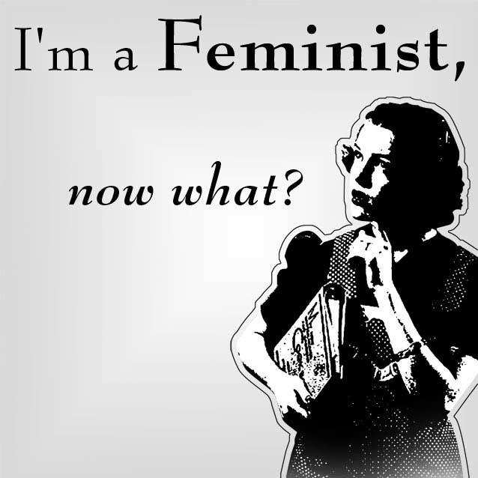

Class 2 (Jan. 24): Doing Feminist Theory
What is feminist theory? What is it good for?

Charlotte Bunch, 1979, “Not by Degrees: Feminist Theory and Education” in Passionate Politics: Feminist Theory in Action, Macmillan: 240-253.
Check out this film clip about Bunch.

bell hooks, 1991, “Theory as Liberatory Practice.”
Check out this brief clip of bell hooks speaking about voice.

Class 3 (Jan. 26): Feminist Methodology
How does a standpoint theory expand knowledge, including feminist knowledge?

Sandra Harding, 2004, “Introduction: Standpoint Theory as a Site of Political, Philosophic, and Scientific Debate,” The Feminist Standpoint Theory Reader, Routledge: Ch. 1.

Uma Narayan, 2004, “The Project of Feminist Epistemology: Perspectives from a Nonwestern Feminist” in The Feminist Standpoint Theory Reader, Routledge: 213-224.

Bette S. Tallen, 2016, “How Inclusive is Feminist Political Theory? Questions for Lesbians,” in Alison M. Jaggar, ed., Just Methods: An Interdisciplinary Feminist Reader, Routledge: 205-212.

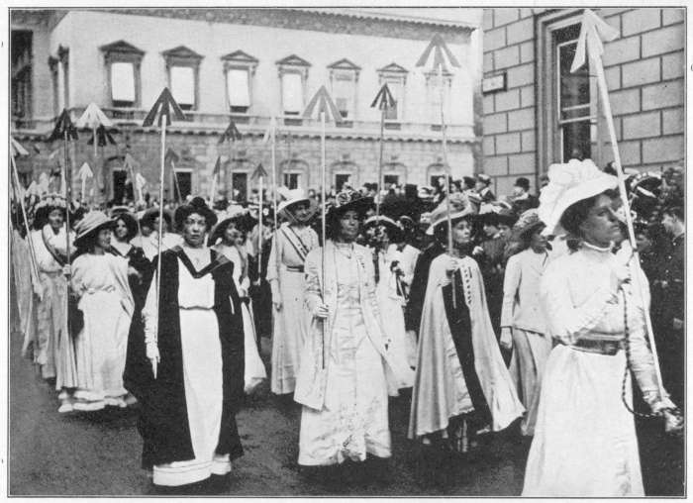

Part II: Early Feminisms
Class 4 (Jan. 31): European, African-American, and Colonial Feminisms*
Which, if any, of these feminisms is liberal?

Mary Wollstonecraft, 1792, Vindication of the Rights of Women: Ch. 1 and 2.

Sojourner Truth, 1867, “Ain’t I A Woman?” “Keeping the Thing Going While Things Are Stirring.”

Bahithat al-Badiya, 1990 [1909], “A Lecture in the Club of the Umma Party” in Margot Badran and Miriam Cooke, eds., Opening the Gates: A Century of Arab Feminist Writing, Indiana University Press: 228-238.

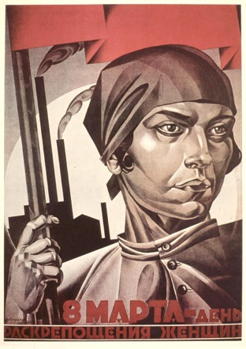

Class 5 (Feb. 2): Socialist and Marxist Feminisms*
What is the source of women’s subordination and why can’t bourgeois feminists end it?

Alexandra Kollontai, 1909, “The Social Basis of the Woman Question.”

Friederich Engels, 2004 [1884], “The Family,” The Origin of the Family, Private Property and the State, Resistance Books: 45-87 (Ch. II in all versions).

Part III. Mid-20th Century Feminisms
Class 6 (Feb. 7): Existential Feminism*
What is a woman?

Toril Moi, 1999, What is a Woman? And Other Essays, New York: Oxford University Press: 10-21.

Simone de Beauvoir, 1949, “Introduction” to The Second Sex (SW #1).

Interview with Simone de Beauvoir, 1976, “The Second Sex 25 Years Later,” Society, Jan-Feb.

Judith Thurman, 2012, “Todd Aiken and the Second Sex,” The New Yorker August 27.

Class 7 (Feb. 9): Liberal Feminisms*
What is the feminine mystique and why is it so persistent?

Betty Friedan, 1963, The Feminine Mystique, W.W. Norton & Company, Reprint edition (2013): Ch. 1-3.

Susan Faludi, 1991, Backlash, W.W. Norton & Company: Ch. 1.

Class 8 (Feb. 14): Radical Feminisms*
Is sex emancipatory, or is it a source of women’s oppression?

Gayle Rubin, 1984, Thinking Sex: Notes for a Radical Theory of the Politics of Sexuality, in Carole S. Vance, ed., Pleasure and Danger: Exploring Female Sexuality, Pandora Press: Ch. 9.

Catharine MacKinnon, 1989, “Sexuality,” Toward a Feminist Theory of the State, (SW #10). NB: The online version is about 4 paragraphs longer than the SW version.

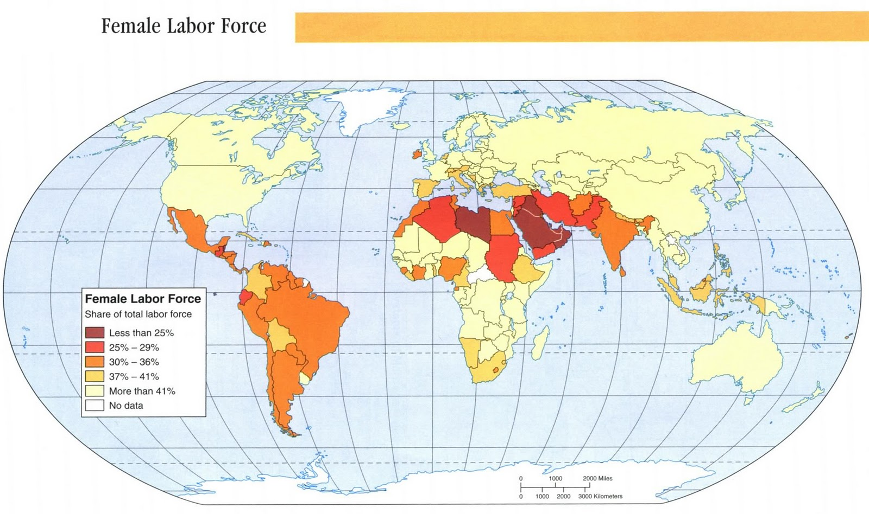

Class 9 (Feb. 16): Socialist Feminisms*
Can work outside the home set women free?

Margaret Bentson, 1969[1984] “The Political Economy of Women’s Liberation”
in Feminist Frameworks, 2nd edition: 240-247.

Heidi Hartmann, 1976, “Capitalism, Patriarchy, and Job Segregation by Sex.” Signs 1 (3): 137-169.

*Recommended Event
Friday, February 17
Professor Dorothy Roberts
Co-sponsored by the School of Medicine’s Office of Diversity and the Power, Violence & Inequality Collective in the College of Arts & Sciences
Time: 12:00-1:30
Place: Pinn Hall Auditorium
Lunch included, book signing to follow

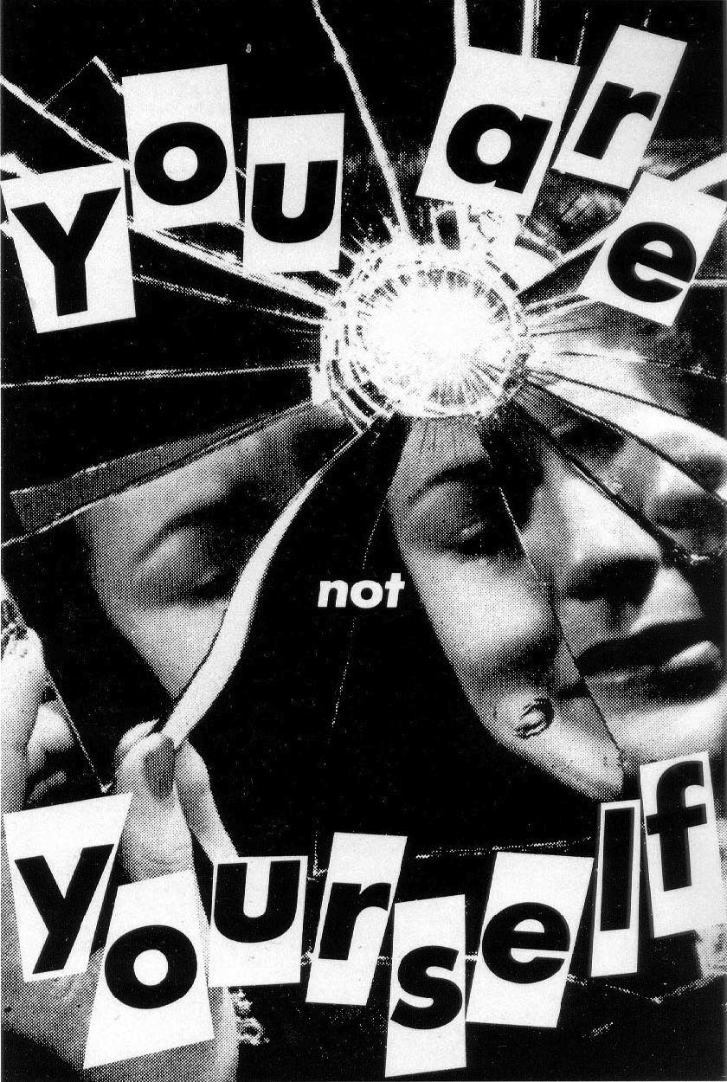

Part IV. Late 20th Century Feminisms
Class 10 (Feb. 21): Postmodern Feminisms
Is there an authentic self? Do “women” exist? If not, what happens to feminism?

Sandra Lee Bartky, 1988, “Foucault, Femininity and the Modernization of Patriarchal Power,” Ch. 3.

Judith Butler, 1990, “Bodily Inscriptions, Performative Subversions,” Gender Trouble: Feminism and the Subversion of Identity, Routledge: 128-141 (focus on 134-141).

Class 11 (Feb. 23): CLASS CANCELLED

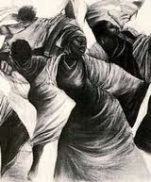

Class 12 (Feb. 28): Black Feminisms*
Do Black feminists focus more on interlocking sources of oppression or identity? Why?

Audre Lorde, 1984, “The Master’s Tools Will Never Dismantle the Master’s House”
Combahee River Collective, 1977, “A Black Feminist Statement,” (SW #4).

Patricia Hill Collins, 2000 (2nd edition), "The Politics of Black Feminist Thought," in Black Feminist Thought: Knowledge, Consciousness, and the Politics of Empowerment, (SW #14).

Class 13 (March 2): Women of Color Feminisms*
How can feminism avoid endless fragmentation?

Chela Sandoval, 1991,“U.S. Third World Feminism: The Theory and Method of Oppositional Consciousness in a Post-Modern World,” Genders 10: 1-24.

Norma Alarcon, 1992, “Chicana Feminism: In the Tracks of ‘The’ Native Woman,” in 63-71.

Maxine Baca Zinn and Bonnie Thornton Dill, 1996, “Theorizing Difference from Multiracial Feminism,” Feminist Studies 22 (2): 321-331.

Spring Break: March 4-12, 2017

Class 14 (March 14): Postcolonial Feminisms*
Does postcolonial feminism endorse cultural relativism? Why or why not?

If you have not yet read Mohanty’s 1988 piece, read that. If you have read it, read her 1997 piece. Everyone reads Mies.

Chandra Talpade Mohanty, 1988, “Under Western Eyes: Feminist Scholarship and Colonialist Discourses,” in Power, Representation, and Feminist Critique: 51-80.

Chandra Talpade Mohanty, 1997, “Women Workers and Capitalist Scripts: Ideologies of Domination, Common Interests, and the Politics of Solidarity” in Feminist Genealogies, Colonial Legacies, Democratic Futures: 3-29.

Maria Mies, 1998, “Women Under Colonialism,” Patriarchy and Accumulation on a World Scale: Women in the International Division of Labour, Zed Books, 2nd edition: 90-111.

Class 15 (March 16): Queer Theories*
Should queer theorists treat identity as a stumbling block or endorse multiplicity?

Judith Butler, 1993, “Imitation and Gender Insubordination,” (SW #18).

Judith Halberstam, 1998, Female Masculinity, Duke University Press: 1-44.

*Recommended Event
Friday, March 17
Keynote Panel: Global Black Girl Politics -- Activists Reflect on Youth, Justice & Girlhood
Global History of Black Girlhood Conference
Time: 6:30-8pm
Place: Minor Hall Room 125

Part VI. 21st Century Feminisms
Class 16 (March 21): Third Wave Feminisms*
This course does not ignore feminist “waves” but is not organized around them. Why not? Was the “Third Wave” a movement?

Claire R. Snyder, 2008, “What is Third Wave Feminism? A New Directions Essay.” Signs: Journal of Women in Culture and Society 34(1): 175–196.

Kimberly Springer, 2002, “Third Wave Black Feminism?” Signs 27(4): 1059-1082.

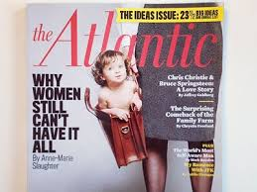

Class 17 (March 23): Postfeminisms and Neoliberal Feminisms*
Are Hillary Clinton, Oprah Winfrey, and Ivanka Trump all neoliberal feminists? Why or why not?

Ana Jordan, 2016, “Conceptualizing Backlash: (UK) Men’s Rights Groups, Anti-Feminism, and Postfeminism” Canadian Journal of Women and Law 28: 18-44.a

Catherine Rottenberg, 2014, “The Rise of Neoliberal Feminism,” Cultural Studies, 28 (3): 418-437.

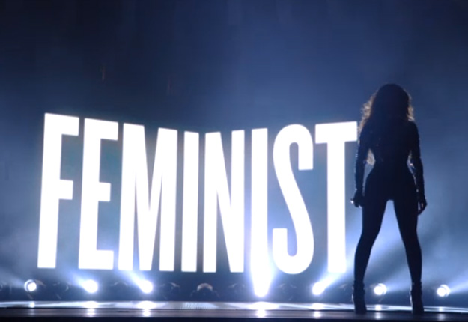

Class 18 (March 28): Feminist Futures
Is the “fourth wave” just the “third wave” awakening as a political movement, a new “wave,” post-neoliberal feminism, or something else? How can these feminists overcome their divisions?

Ealasaid Munro, 2013, “Feminism: A Fourth Wave?” Political Insight, September: 22-25.

Cochrane, 2013, “The Fourth Wave of Feminism: Meet the Rebel Women,” The Guardian, Tuesday, December 10.

Yuanfang Dai, 2016, “Bridging the Divide in Feminism with Transcultural Feminist Solidarity: Using the Example of Forging Friendship and Solidarity between Chinese and U.S. Women,” in Elora Chowdhury, Liz Philipose, eds., Dissident Friendships: Feminism, Imperialism, and Transnational Solidarity, Chicago: University of Illinois Press: Ch. 3 .

*Recommended Event
Wednesday, March 29
Professor Keeanga-Yamahtta Taylor
Sponsored by the Power, Violence & Inequality Collective
Time: 3:30-5:00
“Black Lives Matter in the Trump Era”
Place: Minor Hall 125
Reception to follow

Part V. 21st Century Issues

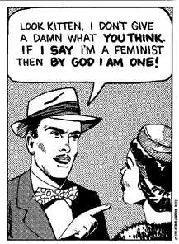

Class 19 (March 30): Masculinities and Men
Should feminists study men or masculinity, or both? Is Grrl Power complicit with hegemonic masculinity? Is it White? Bourgeois? Why or why not?

R. W. Connell, 2005, Masculinities, University of California Press, Ch. 3 and Afterward.

Patricia Hill-Collins, 2004, “Booty Call: Sex, Violence, and Images of Black Masculinity,” Black Sexual Politics: African-Americans, Gender and the New Racism, Routledge: Ch 5.

Recommended film clip: The Bro Code: How Contemporary Culture Creates Sexist Men

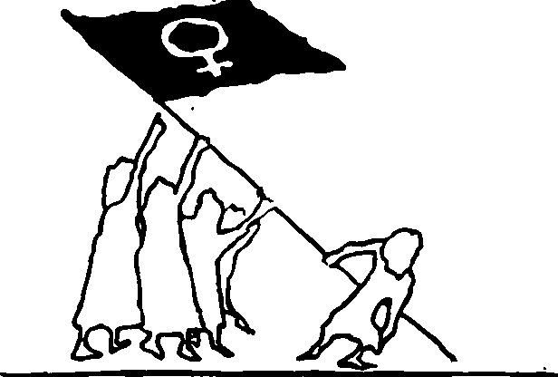

Class 20 (April 4): The War on Terror*
If the war on terror is masculinist and/or homonormative, what does feminism tell us about the war on terror under a Trump presidency?

Iris Marion Young, 2003, “The Logic of Masculinist Protection: Reflections on the Current Security State,” in Marilyn Freedman, Women and Citizenship, Oxford Scholarship Online; also posted on Collab.

Jasbir K. Puar, 2007, Terrorist Assemblages: Homonationalism in Queer Times, Duke University Press: Ch. 1.

Class 21 (April 6): Agency and Choice
What is feminist agency? What is a feminist choice?

Saba Mahmood, 2005, “The Subject of Freedom,” The Politics of Piety, Princeton University Press: 1-39.

Johanna Oksala, 2011, “The Neoliberal Subject of Feminism,” Journal of the British Society for Phenomenology 42, 1: 104–120.

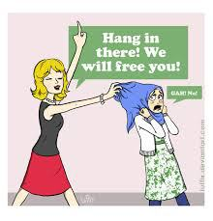

Class 22 (April 11): Feminism and Culture
Why is cultural relativism not feminist? Which feminist approach do you prefer to cultural relativism, and why?

Linda Zerelli, 2009 “Toward a Feminist Theory of Judgment,” Signs 34(2): 295-317.

Denise Walsh, forthcoming, “Multiculturalism and Women’s Rights,” Oxford Handbook of International Political Theory, Oxford University Press.

Class 23 (April 13): Feminism and Climate Change*
Which is more emancipatory: an intersectional approach to climate change or an ecofeminist approach? Why?

Anna Kaljser and Annica Kronseil, 2013, “Climate Change through the Lens of Intersectionality,” Environmental Politics 23(3): 417-433.

Sherilyn Macgregor, 2014, “Only Resist: Feminist Ecological Citizenship and the Post-politics of Climate Change,” Hypatia 29(3): 617-633.

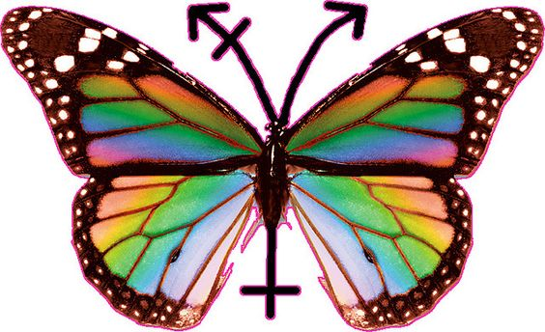

Class 24 (April 18): Feminist Theory and Transgender*
How might feminists best theorize trans*? Why does it matter?

Susan Stryker, 2006, “(De)subjugated Knowledges: An Introduction to Transgender Studies,” in Stryker. S and Whittle S. eds., The Transgender Studies Reader, New York: Routledge: 1-18.

Talia Mae Bettcher, 2014, “‘Trapped in the Wrong Theory’: Re-Thinking Trans Oppression and Resistance,” Signs 39(2): 383-406.

*Recommended Event
Wednesday, April 19
Professor and Assoc. Dean for Graduate Studies, Kathleen Blee
Time: 3:30-5pm
Place: TBA
Reception to follow

Class 25 (April 20): Feminists and Black Lives Matter *
Which question that Jackson asks do you think is the most challenging and why? Does Richie help you to answer it? Why or why not?

Beth Richie, 2012, “The Matrix: A Black Feminist Response to Male Violence and the State,” in Arrested Justice: Black Women, Violence and the American Prison System, Ch. 5 (Virgo ebook).

Cathy J. Cohen and Sarah J. Jackson, 2015, “Ask a Feminist: A Conversation with Cathy Cohen on Black Lives Matter, Feminism, and Contemporary Activism,” Signs 41 (4): 1-22.

Film Trailer: 13th

Class 26 (April 25): Doing Feminist Research
What is feminist research and how do you do it?

Brooke Ackerly and Jacqui True, 2010, Doing Feminist Research in Political Science and Social Science, Ch. 1 and 2.

Shaun McNiff, 2008, “Art-based Research,” in J. Gary Knowles, Ardra L. Cole, eds., Handbook of the Arts in Qualitative Research: 29-40.

Bess Sadler and Chris Bourg, 2015, “Feminism and the Future of Library Discovery,” code{4}lib Journal, Issue 28

Regardless of topic and medium, most students will turn in some writing with their project. Read the discussion about how to do a research paper for strategies on how to narrow your research project topic and more. For general tips browse this site; and check out this last one for strategies on how to make a convincing argument.

Guest speaker: Ms. Erin Pappas, WGS Librarian

Class 27 (April 27): Preparing a Feminist Research Proposal
What is a good feminist research question? What is the difference between a reason and evidence?

Brooke Ackerly and Jacqui True, 2010, Doing Feminist Research in Political Science and Social Science, Ch. 3 and 4.

Chris Sullivan, “Writing an Artist Proposal,” The Career + Co-op Center, School of the Art Institute of Chicago.

Click here for a parody of Mary Kate Olson on the difference between reasons and evidence, and here for a clip from the TV show “Mythbusters” on evidence.

Guest Speaker: Khristian Smith, UVa Writing Center.

At the end of class, students will work in small groups to develop their individual research projects.

*Your research proposal is due next class. It needs a question that you hope to answer. You can’t have an answer until you do the research and complete the project. Remember: A good thesis is contestable, supportable and specific. That means that your research question should invite an answer that is contestable, supportable, and specific.

Class 28 (May 2): Analyzing Feminist Sources
Research Proposals due today on Collab at 11:45pm.
How can you collect data and analyze it? How can you do theory?

Everyone reads:
- Carol A. B. Warren and Tracy Xavia Karner, 2010, Discovering Qualitative Methods: Field Research, Interviews, and Analysis, Oxford University Press: Ch. 9
To read if you are doing interviews:
- Ch. 6 and 7
To read if you are using images and/or historical documents:
- Ch. 8
To read if you are doing a theory paper that does not have interviews, images, or historical documents:
- Barry K. Beyer, 1990, “What philosophy Offers to the Teaching of Thinking,” Educational Leadership: 55-60.
- Review hooks, Bunch and our Feminist Methodology readings

In-class exercise: bring a hard copy of your research proposal to class.

May 11: Research Project due at 11:30pm as an attached file on Collab
Writing is thinking, and good writing require numerous drafts. For suggestions on how to revise your writing see “Rewriting or Revising.”

