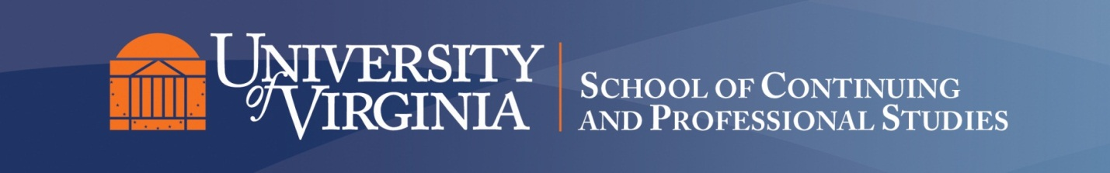
Syllabus/Class Overview Template
Required Components

General Class Information

Instructor Name and Contact Information: Kenny Marotta

Subject Area and Catalog Number: ISLS 3180

Year and Term:2015 Fall

Class Title: Possessing the Past

Level (Graduate or Undergraduate): Undergraduate

Credit Type: Credit

Class Description (Use the SIS 400 characters from catalog description):
We will study various types of efforts to re-experience the
past, including: 1) treasuring its relics 2) imitation and
replication of environments and events 3) reading prose fiction
and watching movies that portray life in the past. We will look
at similarities and differences among these efforts to re-possess
the past, consider them in psychological, historical, and
cultural contexts, and explore some of the issues raised by these
efforts. A major goal of the course will be to sharpen students'
skills in analytical thinking, discussion, and especially the
writing of academic papers.

Required Text (Include ISBN, specific edition):
Toni Morrison, SONG OF SOLOMON (paperback ISBN-10: 140003342X or ISBN-13: 978-1400033423; you may use another edition, though). Other texts will be downloadable from the Collab course website, except when Web addresses are given.

Learning Outcomes:
In addition to becoming familiar with the
subject matter and issues pertinent to it, the student will be
given an introduction to the critical thinking skills necessary
to success in upper-level academic courses. These skills include
thinking analytically (interpreting rather than reiterating
evidence, detecting hidden assumptions, attentiveness to
complexity and nuance) and constructing a persuasive argument
(devising a thesis, providing and interpreting evidence, engaging
counter-arguments, showing sensitivity to objectivity and bias,
creating a logical structure, drawing significant conclusions).

Assessment Components:

Each revised paper will count as 25% of
the final grade. The reading logs together will count as 10% of
the grade. Class participation will count as 15% of the grade.
Rubrics will be handed out with each assignment, indicating the
criteria for grading. Reading logs will not be given a letter
grade, but must be handed in each week; late submissions will
receive 1/2 credit. Level and quality of participation will be
evaluated by attendance (after one missed class, each additional
class missed--for any reason--will lower this grade by one full
letter grade), active engagement in small-group discussion, and
contributions to large-group discussion.

NOTE ON GRADING OF PAPERS: 1) Failure to submit a draft prior to
a revision will result in the lowering of the grade for the
revised version by one full letter grade. 2) All revised papers
may be revised again after grading, to receive a new grade, as
often as you wish until the last class meeting. 3) NOTE: An average
minimum grade of C on all papers combined is necessary to receive
a final grade of C for the course.

Delivery Mode Expectations (Classroom/Internet and Web-based classes, specify any live (synchronous) meetings, dates, times, and location of delivery):

In-person classes. Note: September 28 class will meet in classroom TBA, and include visit to the Small Library.

Required Technical Resources and Technical Components:

Technical Specifications: Computer Hardware:
Computer with basic audio/video output equipment
Internet access (broadband recommended)
Microsoft Word

