ENEC 4500/8500: Samuel Johnson: From Print to Digital Media

Spring 2015
John O’Brien
Office Hours: Tuesdays, 10-12; Wednesdays 10-11
jobrien@virginia.edu

924-6647 (office)
409-1464 (cell)

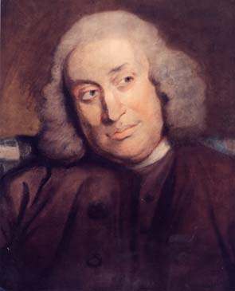
This is a course in the career of Samuel Johnson, the most important literary figure in eighteenth-century English writing. Johnson (1709-1784) was a poet, critic, journalist, editor, playwright, novelist, lexicographer, media celebrity, and much more. We will read a good-sized part of Johnson’s prodigious output in poetry, essay-writing, fiction, literary criticism, and lexicography. But an important fact that shaped Johnson’s writing career—as he knew very well—was the print media of his era and the evolution of its institutions: the printers, editors, booksellers, publishers, and even the lawyers who were helping create the new concept of authorial copyright. We are in a particularly good position to examine Johnson and the media culture that he lived in, because we are living in a time when media is transforming from print to digital formats. We will not only read Johnson and writings about his culture with that in view, we will get our hands dirty, contributing to the process of bringing this part of our cultural heritage into the digital future by editing works by Johnson that will be available on the web for other students and readers. My main target is the fiction now known as Rasselas, which has become Johnson's most-frequently-read work in our era. We may also do something else, such as mapping the itinerary of Johnson and Boswell's tour of the Hebrides using Neatline. Much will depend on your interests and ideas--I want to think about what is useful for you, and what you think will be useful for others.

Requirements:
Reading and active, fervent class participation (20%)
For undergraduates: three essays (one 3-5 pp; two others 5-7 pp) (30 %)
For graduates: two essays (one 3-5 pp; one 12-15 pages)
Participation in group digital project (30%)
Final examination (20%)

Textbooks (please purchase these editions, which are now [or soon will be] available at the University Bookstore):
Samuel Johnson: The Major Works, ed. Donald Greene
Samuel Johnson: A Dictionary of the English Language: An Anthology, ed. David Crystal
Samuel Johnson and James Boswell: A Journey to the Western Islands of Scotland and A Journal of a Tour to the Hebrides
Samuel Johnson: The Lives of the Poets: A Selection, ed. John Mullan and Roger Lonsdale

Schedule of Class meetings and Readings (subject to change)

I: Johnson the Hack: Grub Street and the Eighteenth-Century Writer

January 12—Introduction to the course
14: early poetry: Johnson, " Translation of Horace, Odes, ii.20,” Greene, 1; WordPress blog page; sample of Irene (Greene, 21-23)
--John Dryden, “Preface” to “Ovid’s Epistles, Translated by Several
Hands” (Collab)
--Wikipedia article on Samuel Johnson

19--no class meeting; MLK holiday
21--early journalism: Johnson, “The State of Affairs in Lilliput,” (Greene, 44-50); “Debates in the Senate of Lilliput,” (Greene, 103-112); Letter to Edward Cave (Green, 781), “The Life of Dr Herman Boerhave” (Greene, 54-70); On Gay’s Epitaph” (Green, 51-53)
--Dustin Griffin, “Authorship,” (Collab)
--O. M. Brack, "Publication" (Collab)

26--Johnson, London: A Poem in Imitation of the Third Satire of Juvenal in Greene and/or WordPress site
Matt Kirschenbaum: "What is Digital Humanities and What is it Doing
in English Departments?"
28-- Special Collections session: meet at Byrd-Morrison room, Harrison Institute
First short essay due for all

February 2--The Vanity of Human Wishes (first half)
4--The Vanity of Human Wishes (conclude)
read "Creating and Documenting Electronic Texts: A Guide to Good Practice"
http://ota.ahds.ac.uk/documents/creating/cdet/
read Mark Sample, "The Digital Humanities in not about building, it's
about sharing" http://www.samplereality.com/2011/05/25/the-digital-humanities- is-not-about-building-its-about-sharing/

9--WordPress tutorial with Jeremy Boggs, Scholars Lab; meet in Alderman Library
11--An Account of the Life of Richard Savage, Son of the Earl Rivers (Mullan and Lonsdale)

II. Dictionary Johnson and The Rambler

14--Plan of an English Dictionary (Chrystal 3-12; read his introduction as well)
18--Preface to the English Dictionary (Chrystal 21-42)

23--The Rambler (issues to come)
25--Rambler (issues to come)

4--The Prince of Abissinia (a/k/a Rasselas)
6--Prince, continued

9--Spring
11--Break

16--Rasselas project (readings, work tba--possible in a lab space)
18--Rasselas project
Undergraduates: second essay due

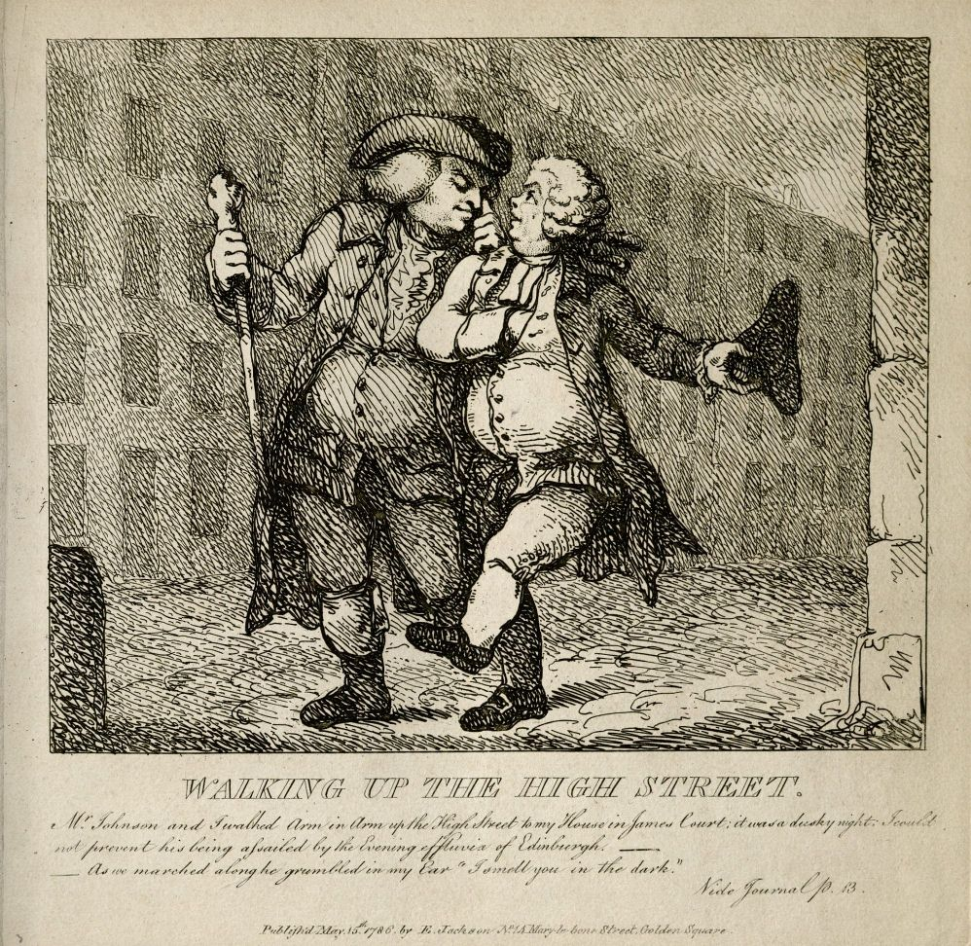

III. Proto-Anthropology; Proto-Biography: Johnson and Boswell go on the road

23--Johnson: A Journey to the Western Islands of Scotland
25--Journey, continued
secondary readings tba

30--Boswell: A Journal of a Tour to the Hebrides with Samuel Johnson
1--Boswell continued

III “Little Lives, and Little Prefaces”: Johnson, Copyright, and the Canon of English Poetry

6-- Johnson, "Advertisement," Life of Cowley
Mullan, Lonsdale, "Introduction"
Mark Rose on copyright (Collab)

8-- Johnson, Life of Grey (Mullan and Lonsdale)
Grey, “Elegy Written in a Country Churchyard” (Collab)

13-- John Milton,"Lycidas" (Collab)
15-- Johnson, Life of Milton (Mullan and Lonsdale)

20- Pope, "The Rape of the Lock" (Collab)
22-- Johnson, Life of Pope (Mullan and Lonsdale)

27-- final class meeting: Johnson, "On the Death of Dr Robert Levet"
all: final essay due

take home final examination

