Chem 5570
Luminescence: Selected Topics in Analytical Chemistry
James Demas (demas@virginia.edu)
CHEM 143
TuTh 8:00AM - 9:15AM CHEM 411
Fall 2015

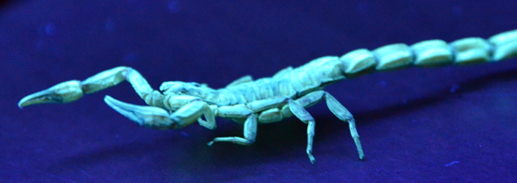
Scorpion fluorescing under a black light

Luminescence is beautiful and practical, and this course will introduce you to both aspects. The course is designed as an introduction and is for upper level undergraduates and graduate students. It starts from the bottom and works up to sophisticated measurements and applications. Topics to be covered will include:

Fluorescence and phosphorescence
Sources of luminescence
Luminescence of organic and inorganic molecules
Fluorescent proteins
Sequencing
Kinetics
Quenching
Energy transfer including FRET
Polarization (static and dynamic)
Excited state reactions
Instrumental methods
Steady state and time resolved measurements
Quantum yield determinations
Data analysis
Microscopy
Single molecule detection
Analytical applications
Sensors
Fluoroimmunoassay
Labeling
Ultralow-level detection
Environmental and bio-monitoring

The course is intended as a practical introduction to luminescence and photochemistry. Theory will be minimized. Topics can be tailored for the specific interests of the students.

Requirements: The student should have calculus and some basic physical chemistry. Familiarity with a fitting/graphing program such Excel is required.

The course will have homework, a written midterm, and a final, each followed by an oral exam over the material. Students will make a presentation on their choice of some aspect of luminescence or photochemistry.

The text will be the third edition of Joe Lakowicz’s Principles of Fluorescence Spectroscopy, literature readings, and internet material.

We will have lab tours of some the University facilities.

