Professor Fred Damon
ANTH 3590-003 (19555)
Anthropology of Time and Space
Fall, 2013
MW 5:00-6:15

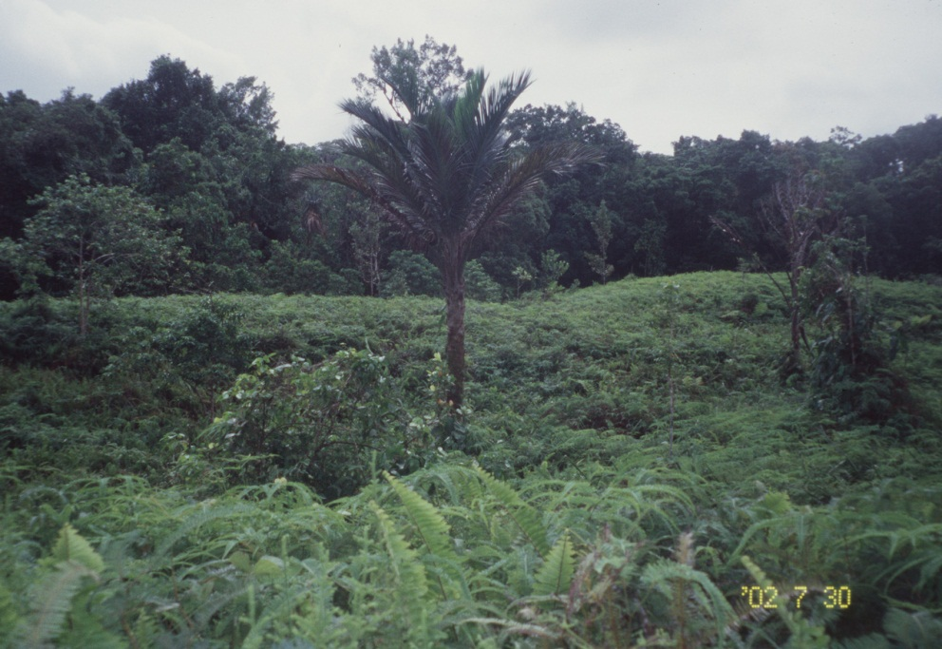
The Creator’s Sago Tree
In an ENSO-generated meadow, Bungalau
in the high forest of Muyuw, Woodlark Island
in Milne Bay Province, Papua New Guinea

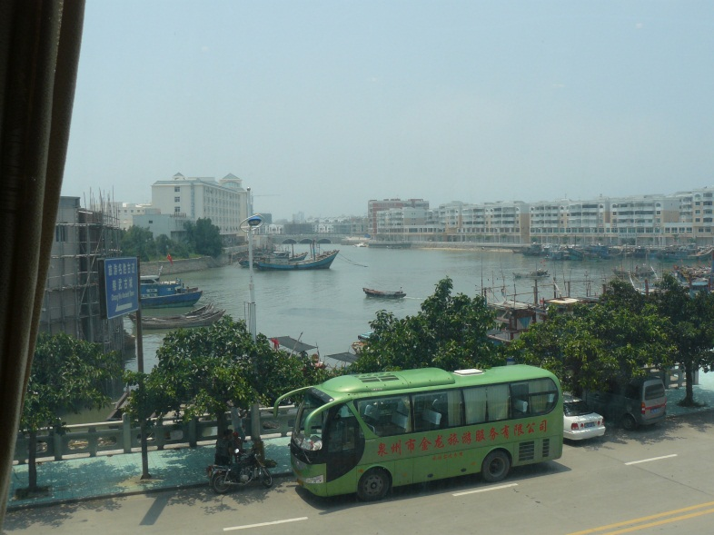 | 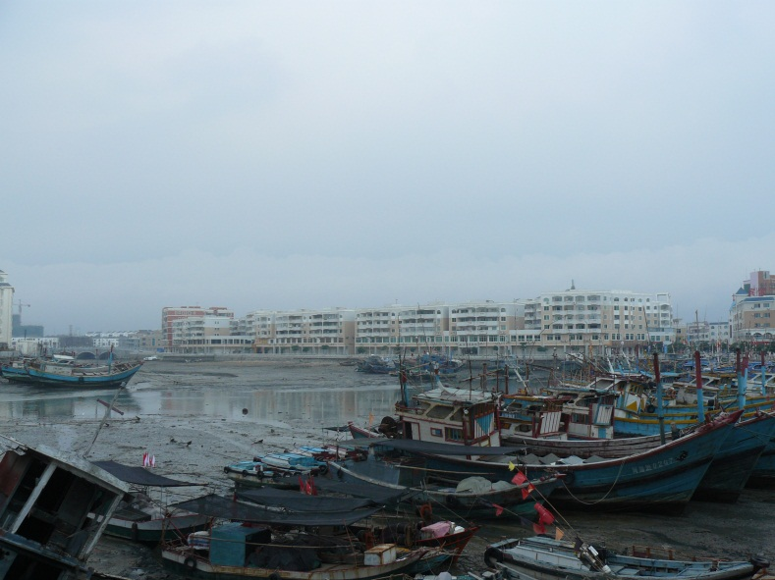
High Tide and Low Tide in Hui An Chongwu (惠安崇武),
Quanzhou, Fujian Province, Peoples Republic of China

